Tasmanian Acute Public Hospitals
Healthcare Associated Infection Surveillance Report 34 – Annual Report 2016 - 17
Tasmanian Acute public Hospital Healthcare Associated Infection Surveillance Report 34 – Annual Report 2016 - 17
Department of Health and Human Services, Tasmania
Published 2017
Copyright—Department of Health and Human Services
Permission to copy is granted provided the source is acknowledged
Authors
- Ms Fiona Wilson, Clinical Nurse Consultant, TIPCU
- Dr Tara Anderson, Specialist Medical Advisor, TIPCU
- Ms Anne Wells, Assistant Director of Nursing, TIPCU
Suggested reference: Wilson, F., Anderson, T., Wells, A. (2017). Tasmanian Acute Public Hospitals Healthcare Associated Infection Report No 34 – Annual Report 2016 - 17. Hobart: Department of Health and Human Services.
Reviewed and approved by the Tasmanian Healthcare Associated Infection Advisory Committee and the Director of Public Health, DHHS Tasmania.
Notes
Data are subject to ongoing revision so data from previous reports should not be relied upon. Use the most up to date report when citing data.

Contents
Executive summary 6
Achievements 7
Staphylococcus aureus bacteraemia 8
Tasmanian rates 8
Hospital rates 10
HCA SAB related to MSSA or MRSA 11
HCA SAB related to IV devices 12
Community associated SAB 13
Clostridium difficile infection 14
Tasmanian rates 14
Hospital rates – by financial year 17
Vancomycin resistant enterococci 18
VRE screening effort 21
Hand Hygiene 22
Tasmanian rates 22
Antibiotic use surveillance 25
Acknowledgements 28
Appendix 1 29
Explanatory notes 29
Appendix 2 32
Healthcare associated Staphylococcus aureus bacteraemia (SAB) 32
Clostridium difficile infection (CDI) 37
Vancomycin resistant enterococci (VRE) 40
Hand hygiene compliance data June 2017 44

Index of figures and tables
Figure 1 Healthcare associated Staphylococcus aureus bacteraemia - Tasmanian rate by quarter 7
Figure 2 Healthcare associated Staphylococcus aureus bacteraemia rate by financial year 8
Figure 3 Healthcare associated Staphylococcus aureus bacteraemia - rate by quarter 9
Figure 4 Healthcare associated Staphylococcus aureus bacteraemia - rate by financial year 9
Figure 5 Healthcare associated MSSA and MRSA SAB – number by financial year 10
Figure 6 Total IV device related HCA SAB – number and percentage by financial year 11
Figure 7 Community associated CA-SAB – number and incidence/100 000 population 12
Figure 8 Community associated CA-SAB – number of MSSA and MRSA/financial year 12
Figure 9 Acute public hospital identified CDI and HCA-HCF CDI – rates by quarter 13
Figure 10 Hospital identified and HCA-HCF CDI - rate by financial year 14
Figure 11 Hospital identified CDI by quarter 15
Figure 12 HCA-HCF CDI by quarter 15
Figure 13 Hospital identified CDI by financial year 16
Figure 14 HCA-HCF CDI by financial year 16
Figure 15 First VRE isolates by quarter 17
Figure 16 First VRE isolates – classification by quarter 18
Figure 17 First VRE isolates - genotype by quarter 18
Figure 18 First VRE isolates – classification by financial year 19
Figure 19 First VRE isolates – genotype by financial year 19
Figure 20 Hand hygiene compliance in Tasmanian public hospitals 21
Figure 21 Hand hygiene compliance by moment 22
Figure 22 Hand hygiene compliance by healthcare worker 23
Figure 23 Cephalosporin use 25
Figure 24 Fluoroquinolone use 25
Figure 25 Piperacillin - tazobactam use 26
Figure 26 Vancomycin use 26

Table 1 Proportion of VRE positives from screening specimens 20
Table 2 Healthcare worker categories 23
Table 3 Tasmanian numbers and rate per 10 000 patient days of HCA-SAB. 31
Table 4 Royal Hobart Hospital numbers and rates per10 000 patient days of HCA-SAB 32
Table 5 Launceston General Hospital numbers and rates per10 000 patient days of HCA-SAB 33
Table 6 Mersey Community Hospital numbers and rates per10 000 patient days of HCA-SAB 34
Table 7 North West Regional Hospital numbers and rates per10 000 patient days of HCA-SAB. 35
Table 8 Tasmanian numbers and rates per10 000 patient days of CDI 36
Table 9 Hospital numbers and rates per10 000 patient days of hospital identified CDI 37
Table 10 Hospital numbers and rates per10 000 patient days of HCA-HCF CDI 38
Table 11 First VRE isolates identified per quarter. 39
Table 12 Classification of first VRE isolates – by specimen type 40
Table 13 Classification of first VRE isolates – colonisation and infection 41
Table 14 First VRE isolates by genotype by quarter 42
Table 15 Hand hygiene compliance rates by Tasmanian hospital and state level 43
Table 16 Tasmanian hand hygiene compliance rates by moment 44
Table 17 Tasmanian hand hygiene compliance rates by healthcare worker 44

Executive summary
This report provides an overview of the Tasmanian acute public hospitals’ healthcare associated infection surveillance for the financial year 2016 – 17 and also serves as the report for quarter 2, 2017.
Compared to the quarterly reports, this annual report contains additional detail, such as infection rates by financial year and antibiotic use. Details of the surveillance program, including the rationale for the indicators measured and the methodologies used in data collection, validation and analysis are available at the TIPCU website.
Any form of comparison between hospitals should be done with caution because data are not adjusted for patient characteristics that vary between hospitals. Further, the relatively small Tasmanian population and small number of events can result in volatility of rates from time to time. The raw data in the appendices illustrate this.
This report contains the following findings:
- The rate of healthcare associated Staphylococcus aureus bacteraemia (SAB) remains low and below the National threshold.
- The number of healthcare associated (HCA) SAB secondary to an intravenous (IV) device has not decreased over the past three years.
- There has been a recent increase in both ‘hospital identified Clostridium difficile infection (CDI)’ and ‘hospital identified, healthcare associated-healthcare facility onset (HCA-HCF) CDI’ but the incidence of both remains around the long term average.
- The number of new isolates of VRE continues to increase.
- The consolidated Tasmanian public hospital hand hygiene compliance rate is above the National Benchmark of 80%.
Achievements
2016-17 TIPCU activities that focus on preventing infection include:
Governance
- Commencement of a collaborative project with the Tasmania Health Service (THS) to develop a State-wide infection control policy and suite of accompanying protocols for the THS.
- Continuing participation in national committees under the aegis of Australian Commission of Safety & Quality in Health Care (ACSQHC). These are:
  - Healthcare Associated Infection Advisory Committee.
  - Hand Hygiene Advisory Committee.
  - Australian Healthcare Standards Review Committee - Standard 3 Working Group.
  - Clostridium difficile infection Community of Practice.
  - Antimicrobial Stewardship Committee.
- Participation in the Communicable Diseases Network Australia (CDNA) Multi-drug Resistant Organism Working Group.
- Working with the Communicable Diseases Prevention Unit (CDPU) and Environmental Health Services within Public Health Services (PHS).
- Collaboration with Environmental Health Services to develop the ‘Environmental Health Risk Management and Infection Control for Tourism Businesses’.
Education and Training
- Ongoing education provided to a range of groups including aged care graduate nurses, Environmental Health Officers, Department of Education child support staff and health industry representative through Work Safe Tasmania.
Surveillance
- Continuation of surveillance programs based on nationally agreed methodology and Tasmanian notifiable microorganisms.
- Development of a Central Line Associated Blood Stream Infection (CLABSI) Surveillance protocol.
- Participation in the National Alert System for Critical Antimicrobial Resistances (CAR Alert).
- Continued provision of an environmental cleaning assessment program.
- Continuation of a surveillance program for antimicrobial use in rural hospitals.

Staphylococcus aureus bacteraemia
Staphylococcus aureus, a common cause of serious healthcare associated bloodstream infection (bacteraemia), may cause significant patient morbidity and mortality. Many healthcare associated Staphylococcus aureus bacteraemias (SAB) are preventable. SAB was made notifiable in Tasmania in 2008 pursuant to the Public Health Act 1997. Tasmania was the first and remains the only Australian jurisdiction to introduce this measure.
SAB surveillance is carried out in Tasmania using the national surveillance definitions published by the Australian Commission on Safety and Quality in Health Care (ACSQHC). Under this definition a SAB is defined as healthcare associated if the patient’s first SAB positive blood culture was collected either >48 hours after hospital admission or <48 hours after discharge (Criterion A) OR ≤48 hours after hospital admission and one of four key clinical healthcare related criteria was met (Criterion B).
The National Healthcare Agreement (2011) target is no more than two HCA SAB per10 000 patient days.

Tasmanian rates
Figure 1 and Figure 2 present the Tasmanian acute public hospital rates of healthcare associated Staphylococcus aureus bacteraemia (HCA SAB) by quarter. This information is also contained in tables within the appendix.
Figure 1 Healthcare associated Staphylococcus aureus bacteraemia - Tasmanian rate by quarter
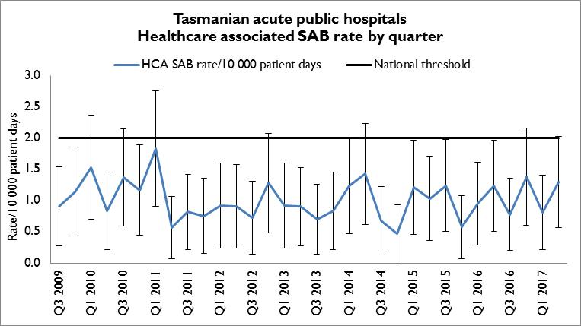

The rate of HCA SAB for Q2 2017 was 1.3 per 10 000 patient days (95% CI 0.6 – 2.0) which met the National Healthcare Agreement target of no more than two HCA SAB per10 000 patient days.

Figure 2 Healthcare associated Staphylococcus aureus bacteraemia rate by financial year
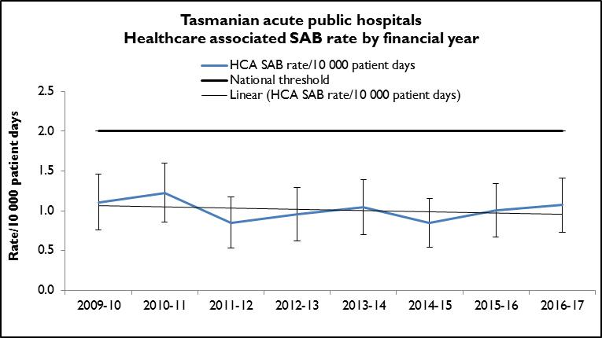

The public hospital combined rate of HCA SAB for 2016-17 was 1.1 per 10 000 patient days (95% CI 0.7 – 1.4). The annual rate of HCA SAB has remained stable for the past five years.

Hospital rates
Figure 3 presents the individual acute public hospitals rates of HCA SAB by quarter and Figure 4 presents HCA SAB for the individual acute public hospitals by financial year. This information is also contained in tables within the appendix.
Figure 3 Healthcare associated Staphylococcus aureus bacteraemia - rate by quarter
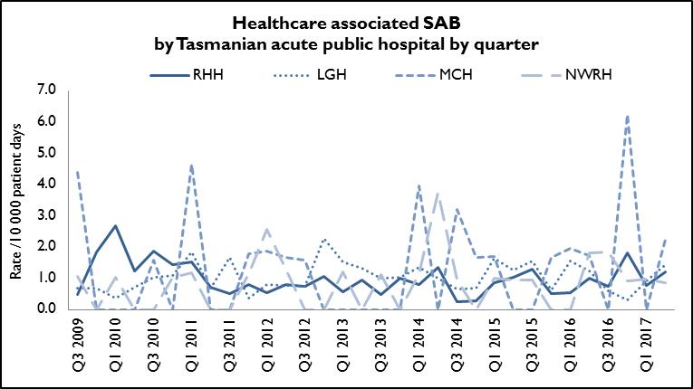
Figure 4 Healthcare associated Staphylococcus aureus bacteraemia - rate by financial year
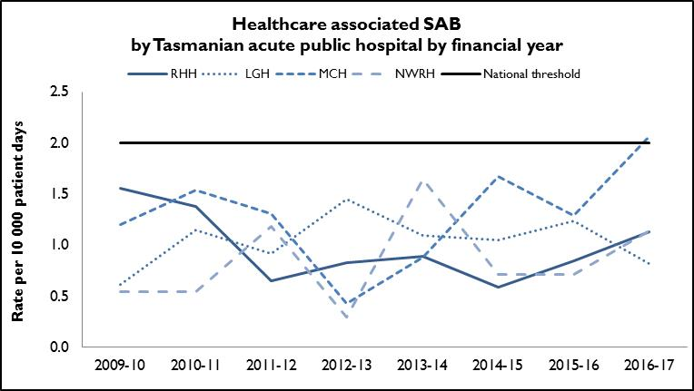
In 2016 - 17, there were four HCA SAB identified at the MCH. Based on the small number of patient days at MCH, the annual HCA SAB rate for MCH exceeds the National Healthcare Agreement target of no more than two HCA SAB per10 000 patient days.
The annual HCA SAB rate for RHH, LGH and NWRH for 2016 - 17 was less than the National Healthcare Agreement target of no more than two HCA SAB per10 000 patient days.

HCA SAB related to MSSA or MRSA
Figure 5 presents HCA SAB according to susceptibility; methicillin sensitive Staphylococcus aureus (HCA-MSSA) and methicillin resistant Staphylococcus aureus (HCA-MRSA) by financial year.
Figure 5 Healthcare associated MSSA and MRSA SAB – number by financial year
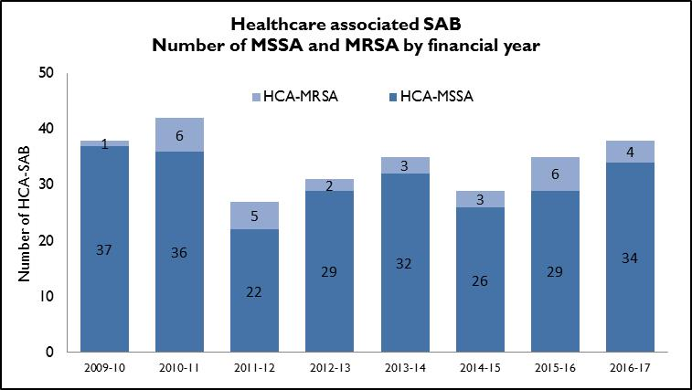
The total number of HCA SAB remains low and stable. The majority remain MSSA but the total number of HCA SAB that are MSSA has continued to increase each financial year since 2013 – 14.

HCA SAB related to IV devices
Healthcare associated SAB are classified where possible into four categories: SAB related to an indwelling medical device, a surgical site, invasive instrumentation or cytotoxic therapy induced neutropenia. TIPCU reports annually on all HCA SAB related to one type of indwelling device – intravenous (IV) devices. Figure 6 presents the number and percentage of IV device related HCA SAB.
Figure 6 Total IV device related HCA SAB – number and percentage by financial year
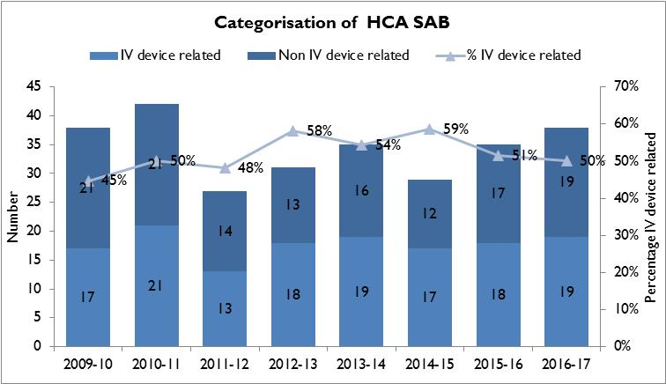
Around half of indwelling device related HCA SAB are related to an IV device and the total number identified per financial year has not decreased over the past 3 years. Infection prevention strategies such as intravenous device management procedures and processes, in conjunction with adherence to aseptic technique principles, can reduce the risk of patients developing a SAB secondary to an IV device. These strategies should be implemented and evaluated in all healthcare settings where IV devices are used.

Community associated SAB
Figure 7 and Figure 8 present the Tasmanian number and incidence/100 000 population of community associated SAB (CA-SAB) by financial year and presents CA-SAB numbers according to antibiotic susceptibility; methicillin sensitive Staphylococcus aureus (CA-MSSA) and methicillin resistant Staphylococcus aureus (CA-MRSA).
Figure 7 Community associated CA-SAB – number and incidence/100 000 population
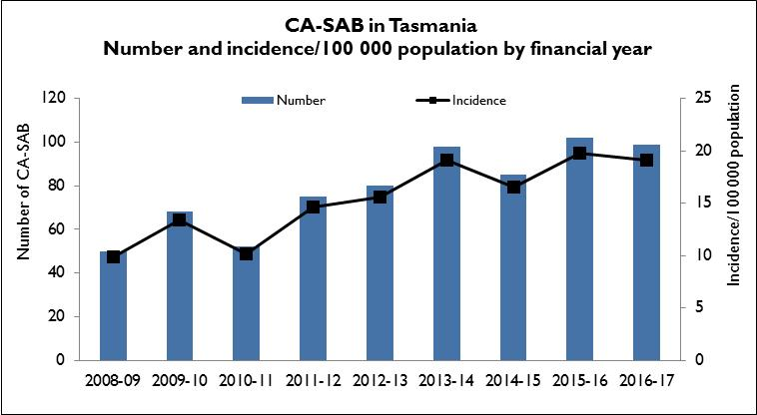
Figure 8 Community associated CA-SAB – number of MSSA and MRSA/financial year
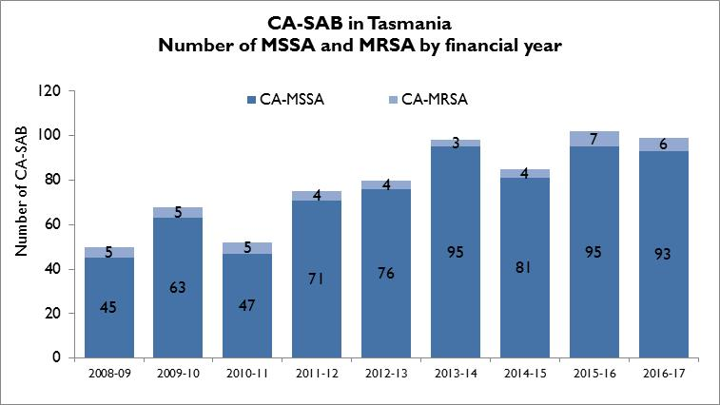
There are three times as many CA-SAB than HCA SAB. It is not possible to compare rates with other jurisdictions as Tasmania is the only state/territory where SAB is a notifiable disease.
The majority of CA-SAB is due to MSSA with the numbers of CA-SAB caused by MRSA remaining at less than 10 per financial year.

Clostridium difficile infection
Clostridium difficile infection (CDI) is a bowel infection caused by the bacterium Clostridium difficile and is a common cause of healthcare associated diarrhoea. CDI causes significant patient morbidity and mortality and can result in increased hospital stays and costs. Factors that may contribute to higher CDI rates include the overuse of antibiotics, ineffective infection control processes and suboptimal environmental cleanliness.
Surveillance of CDI in Tasmania uses the ACSQHC’s national surveillance definitions. There is no National benchmark for CDI.
Hospital identified CDI are CDI infections identified in a hospital irrespective of attribution of infection.
Healthcare associated – healthcare facility onset (HCA-HCF) CDI are a sub-group of hospital identified cases. This category only includes infections that occurred 48 hours or more after a patient was admitted to hospital. The HCA – HCF rate excludes people who present to hospital with symptoms of CDI and/or develop symptoms within two days of admission.

Tasmanian rates
Figure 9 and Figure 10 presents the Tasmanian combined acute public hospital rates of hospital identified CDI and HCA-HCF CDI by quarter and financial year.
Figure 9 Acute public hospital identified CDI and HCA-HCF CDI – rates by quarter
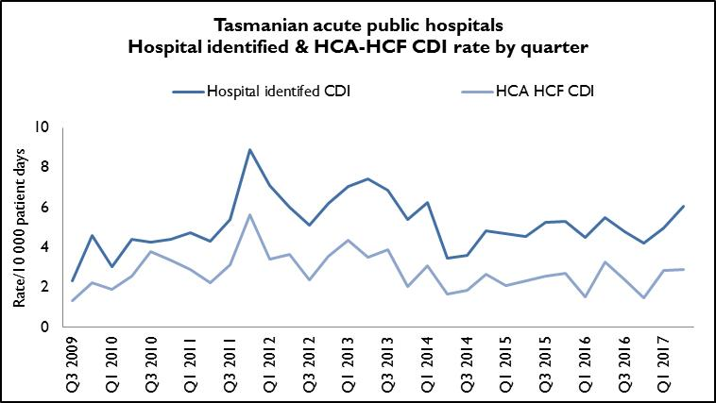
The rate of hospital identified CDI for Q2 2017 was 6.1 per 10 000 patient days (95%
CI 4.4 – 7.7) and the rate of HCA-HCF over the same period was 2.9 per10 000 patient days (95% CI 1.8 – 4.1). This is a recent increase in both hospital identified and HCA-HCF CDI but the incidence of both remains around the long term average.

Figure 10 Hospital identified and HCA-HCF CDI - rate by financial year
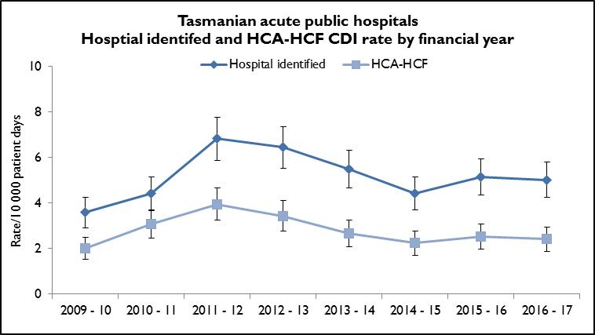
The mean (average) rate of hospital identified CDI for 2016 – 17 was 5.0 per 10 000 patient days (95% CI 4.3 – 5.8) and the mean rate of HCA-HCF CDI over the same period was 2.4 per 10 000 patient days (95% CI 1.9 – 3.0).
The number and rate of hospital identified CDI has increased slightly over the past three years. The annual number and rate of HCA-HCF CDI remains low and has decreased slightly over 2016 - 17.
Hospital rates – by quarter
Figure 11 and Figure 12 presents the individual acute public hospital rates of ‘hospital identified CDI’ and ‘healthcare associated – healthcare facility onset (HCA-HCF) CDI’ by quarter.
Figure 11 Hospital identified CDI by quarter
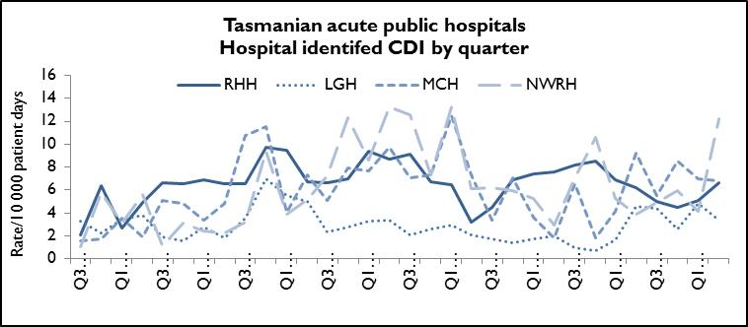

Figure 12 HCA-HCF CDI by quarter
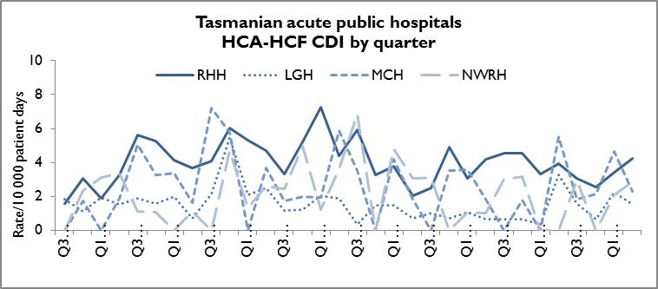
There has been an increase in HCA-HCF CDI over Q2 2017 at RHH. Antimicrobial usage patterns have not significantly changed over this period and no ward based CDI outbreaks have been identified.

Hospital rates – by financial year
Figure 13 and Figure 14 presents the individual acute public hospital rates of hospital identified CDI and healthcare associated – healthcare facility onset (HCA-HCF) CDI by financial year.
Figure 13 Hospital identified CDI by financial year
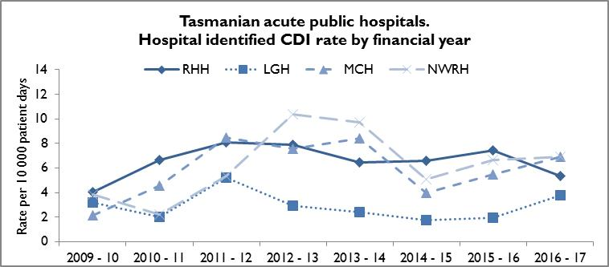
Figure 14 HCA-HCF CDI by financial year
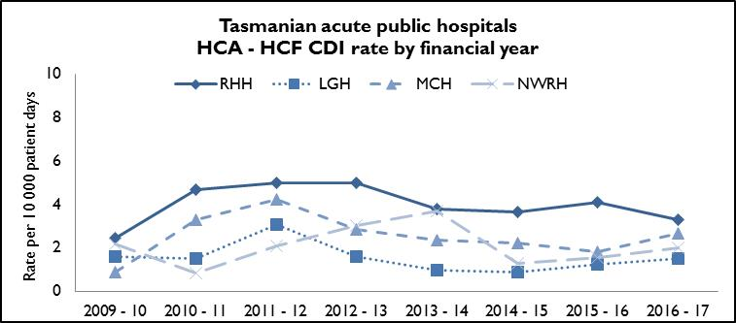
The LGH has demonstrated an upward trend in 2016 – 17 in hospital identified CDI which can be largely explained by a change to laboratory diagnostic algorithm, with enhanced sensitivity for detection of C. difficile infection.
The annual number and rates of HCA-HCF have decreased at RHH over 2016 – 17 despite the increase in cases Q2 2017. The remaining hospitals annual number and rates have remained stable for 2016 – 17.

Vancomycin resistant enterococci
Enterococci are bacteria normally present in the human gastrointestinal and female genital tract and can cause infections of the urinary tract, bloodstream and wounds. Enterococci that have acquired resistance to the antibiotic vancomycin are called vancomycin-resistant enterococci or VRE.
VRE infections can be more difficult to treat then those caused by vancomycin sensitive enterococci. Factors that can contribute to the transmission of VRE in hospitals are ineffective infection control practices, overuse of antibiotics and suboptimal environmental cleanliness.
Identification of VRE is notifiable in Tasmania pursuant to the Public Health Act 1997.
Figure 15 presents all patients with a first VRE isolate identified within Tasmania by quarter. These numbers include all new patients identified within Tasmania from public and private hospitals, rural hospitals, GP clinics and long term and residential care facilities. A person’s first VRE isolate is classified according to whether it was from a screening or clinical specimen.

Figure 15 First VRE isolates by quarter
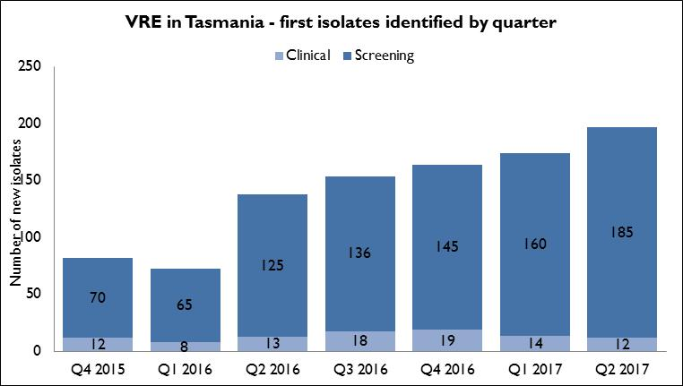
The number of people newly identified with VRE within hospitals does not necessarily reflect that VRE was acquired at that hospital. The numbers of VRE isolates identified can be affected by the amount of screening undertaken by hospitals.
Hospitals that have an intensive screening program are likely to identify more VRE. During the past two years there has been an increase in identification of VRE.
Most isolates over that time have been, and continue to be, screening specimens. In Q2 2017, there were 12 specimens (6%) that were clinical specimens, fewer than the previous two quarters.

Figure 16 First VRE isolates – classification by quarter
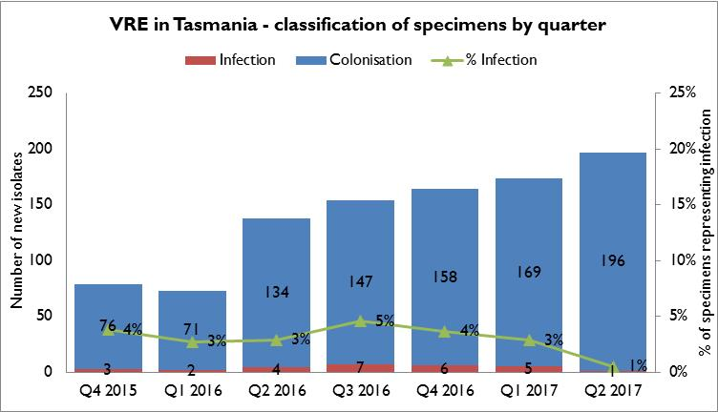
VRE isolates are also classified as to whether they represent colonisation or infection. The proportion of isolates that represent infections has remained stable over the last six quarters with infections representing around 3% of total isolates.
Figure 17 First VRE isolates - genotype by quarter
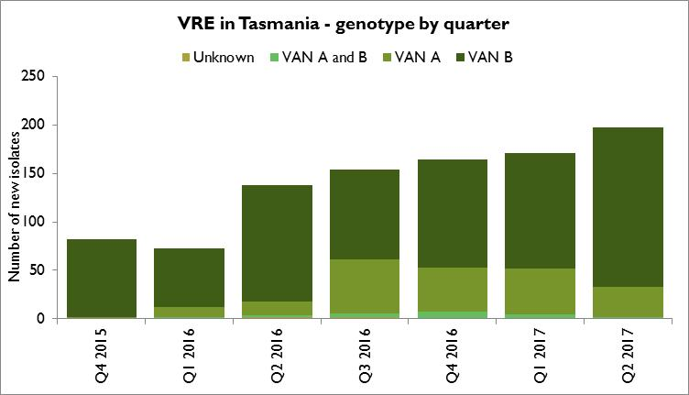
The majority of VRE within Tasmania remains vanB E. faecium. Molecular typing is being undertaken to gain a better understanding of VRE epidemiology within Tasmanian public hospitals.

Figure 18 First VRE isolates – classification by financial year

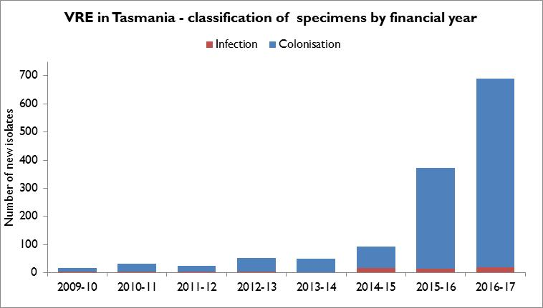
This graph illustrates the large increase in the number of new VRE isolates over the previous two financial years, in particular over 2016 – 17. The increase has been in colonisation with VRE rather than infections which have remained stable over the same period.
Figure 19 First VRE isolates – genotype by financial year

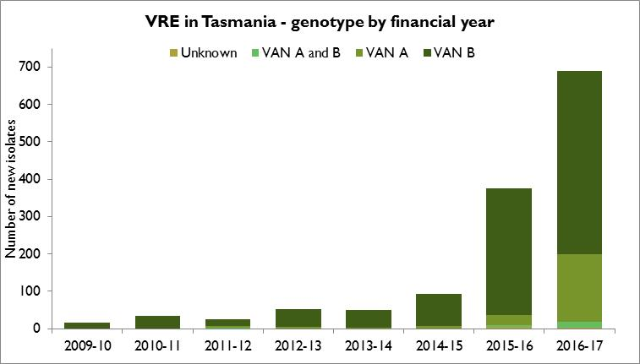
This graph illustrates the increased proportion of new VRE isolates that have the vanA genotype. There has been an increase over the past year in the number and proportion of isolates with the vanA genotype. This is a concern as there are limited antimicrobial choices for treatment of infection with this genotype.

VRE screening effort
The volume of VRE screening has increased in Tasmania in response to the infection control management of VRE within acute public hospitals and possible improved adherence to the THS Statewide screening protocol which includes both high risk patients and high risk clinical settings.
Table 1presents the VRE screening effort across the four larger acute public hospitals, demonstrating the numbers of screening specimens tested, the number of specimens that have cultured VRE and the percentage of screening specimens that cultured VRE.
Table 1 Proportion of VRE positives from screening specimens
Year | RHH  Screening specimens tested | RHH  Positive specimens | LGH  Screening specimens tested | LGH  Positive specimens | MCH  Screening specimens tested | MCH  Positive specimens | NWRH  Screening specimens tested | NWRH  Positive specimens
2014 | 1962 | 12 (0.6%) | 353 | 25 (7.1%) | 544 | 8 (1.5%) | 893 | 11 (1.2%)
2015 | 2077 | 91 (4.4%) | 586 | 52 (8.9%) | 404 | 17 (4.2%) | 962 | 31 (3.2%)
2016 | 3863 | 182 (4.7%) | 1672 | 212 (12.6%) | 426 | 41 (9.6%) | 1094 | 66 (6%)
2017* | 2482 | 158 (6.4%) | 1119 | 151 (13.4%) | 258 | 28 (10.8%) | 510 | 34 (6.6%)
* 6 months of data as based on calendar year
This data shows that there has been an increase in VRE screening effort at both RHH and LGH and an increase in the proportion of positive specimens found across all four larger acute public hospitals over the last two years.
These data have not been de-duplicated so there will be a small number of repeat positive specimens on patients already known to have VRE included in this data set.

Hand Hygiene
The National Hand Hygiene Initiative was introduced in Tasmania in 2009 to increase healthcare workers hand hygiene compliance and monitor its effectiveness by measuring reductions in HCA SAB.
Hand hygiene compliance is monitored by direct observation of healthcare workers performing hand hygiene at the appropriate times.
Hand Hygiene Australia (HHA) requires hand hygiene compliance data to be submitted three times per year.
In 2017 the Australian Health Ministers Advisory Council (AHMAC) endorsed increasing the national compliance benchmark to 80% for total moments, individual moments and each healthcare worker group.

Tasmanian rates
Figure 20 Hand hygiene compliance in Tasmanian public hospitals
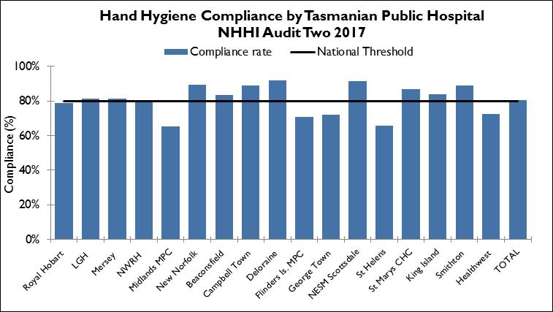
Audit period 2 is from 1 April 2017 to 30 June 2017. For this period the overall Tasmanian public hospital compliance rate was 81 per cent which was above the national threshold of 80 per cent.
The 2016-2017 Service Agreement between the Minister for Health and the Tasmanian Health Service (THS) states the hand hygiene compliance Key Performance Indicator (KPI) target as ≥75% increasing to 80% from 1/1/2017.
For the three audit periods during 2016-2017, the overall THS hospital compliance rate was above the 80% service agreement target.
There are differences in the number of hand hygiene moments observed in the acute hospitals versus the rural hospitals and these numbers are presented in the tables in Table 13 in Appendix 2.
Figure 21 Hand hygiene compliance by moment
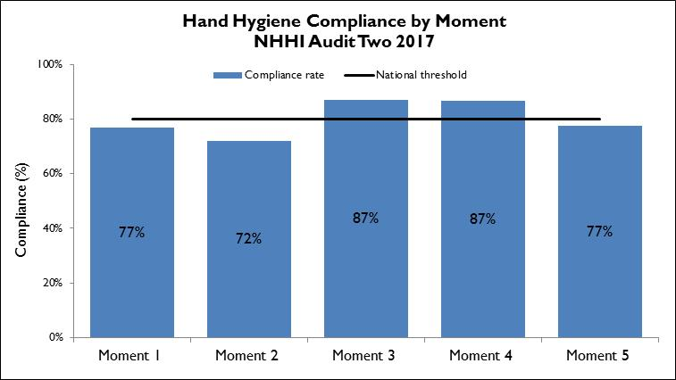
Hand hygiene compliance before touching a patient (Moment 1), undertaking a procedure (Moment 2) and after touching patient surroundings (Moment 5) are lower than the target of 80 per cent and lower than those reported after undertaking a procedure (Moment 3) or after touching a patient (Moment 4). Moment 1 and Moment 2 are key opportunities for hand hygiene that may have a direct effect on the risk of transmission of pathogens within the healthcare setting. Moment 2, particularly relates to compliance with appropriate aseptic technique and procedural activity.
These findings – less complience with Moments 1 and 2 than for Moments 3 and 4 - are consistent with the national data and work continues within Tasmania to increase the compliance in these moments.

Figure 22 Hand hygiene compliance by healthcare worker
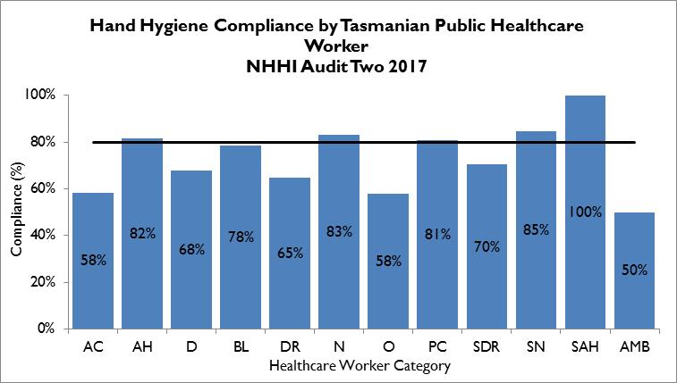
Table 2 Healthcare worker categories
Code | Healthcare worker | Code | Healthcare worker | Code | Healthcare worker
AC | Clerical | DR | Doctor | SDR | Student Doctor
AH | Allied Health | N | Nurse/Midwife | SN | Student Nurse/Midwife
D | Domestic | O | Other | SAH | Student Allied Health
BL | Invasive Technician | PC | Personal Care Staff | AMB | Ambulance worker
There are differences in the number of hand hygiene moments observed within healthcare worker group varies.
Most hand hygiene compliance data (74 per cent in audit period 2, 2017) is collected from nurse-patient interactions with the next highest being doctor-patient interactions (10 per cent).
There are a number of healthcare worker groups that contribute less than one per cent of the total hand hygiene moments thus their results should be interpreted with caution. These group are clerical, invasive technician, student doctor, student allied health care worker, ambulance worker and other.
Of the healthcare worker groups that contribute more than one per cent of the total number of moments, doctors and domestic staff are not meeting the compliance target of 80 per cent.
The number of moments collected in each group is presented in Appendix 2, Table 17.

Antibiotic use surveillance
Antimicrobial use is associated with the emergence of antimicrobial-resistant bacteria. Antimicrobial resistance is a significant and growing threat to public health worldwide. The National Antimicrobial Utilisation Surveillance Program (NAUSP) began in 2004 to conduct surveillance of hospital antimicrobials, principally antibiotic use. The program enables individual institutions to examine their own antimicrobial use rates and trends over time and provides peer group benchmarks for comparison. The data can be used to identify trends in antimicrobial use over time and develop local interventions to promote appropriate antimicrobial use.
The Royal Hobart Hospital has been contributing data to the NAUSP since July 2004 while Launceston General Hospital, North West Regional Hospital and Mersey Community Hospital have been contributing since January 2009. The data presented in this report shows use since January 2015 to April 2017.
Antimicrobial usage rates are calculated using the number of defined daily doses (DDDs) of specific antimicrobial agents or classes consumed each month per 1 000 occupied bed days (OBDs). This is a widely accepted method of measuring antimicrobial use in hospital settings both nationally and internationally. Tasmania uses ‘patient days’ rather than OBDs as the denominator and has done for a number of years. When this was initially introduced, a comparison was done between the two figures and there were no changes in the rates that were calculated.
The Antimicrobial Use and Resistance in Australia 2017 (AURA) report summarises the national NAUSP data and can be found via the following link: https://www.safetyandquality.gov.au/wp-content/uploads/2017/08/AURA-2017-Second-Australian-report-on-Antimicrobial-Use-and-Resistance-in-human-health.pdf . Antibacterial use in Australian hospitals has declined since 2010 to 916 DDD per 1,000 occupied bed days (OBD’s). Five Tasmanian hospitals contribute to NAUSP and the overall rate within the Tasmanian hospitals is 1,220/1000 OBDs (1183-1254/1,000 OBDs), the highest rate within Australia, although comparisons between states are difficult.
Rates presented in this report are for four antimicrobials or antimicrobial classes: third and fourth generation cephalosporins (ceftriaxone, cefotaxime, ceftazidime, cefepime); fluoroquinolones (ciprofloxacin, moxifloxacin, norfloxacin); piperacillin/tazobactam, and vancomycin. These were chosen for their relevance to other indicators in this report. Cephalosporin use has been linked with the emergence of MRSA while cephalosporins and fluoroquinolones have been identified as risk factors for Clostridium difficile infection, and all four classes have been associated with VRE acquisition.
The graphs show the use of the antimicrobial class or specific antimicrobial in each acute hospital. TIPCU use a three point rolling average to calculate the average rate of the current, and two previous months, and uses this to show trends over time. Because Tasmanian hospitals vary in services provided, comparisons between Tasmanian hospitals are not recommended. For example, a hospital that has a dedicated cancer service may use more antimicrobials to combat infections in this susceptible patient group.
Antimicrobial utilisation surveillance is an important component of comprehensive antimicrobial stewardship programs. The Tasmanian Health Service (THS) Antimicrobial Stewardship Program is under development and had its inaugural THS Antimicrobial Stewardship Committee meeting on the 18th September 2017. Antimicrobial usage data helps stakeholders to plan priority strategies to improve antimicrobial prescribing.
Figure 23 Cephalosporin use
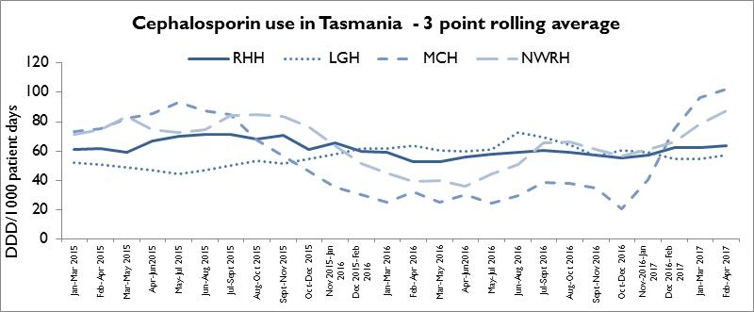
Cephalosporin usage in Tasmanian hospitals is comparable with the AURA 2017 data from NSW/ACT and Victoria but higher than the other states. Cephalosporin usage has been steady at the LGH and the RHH with the most recent usage being approximately 60 DDD per 1000 patient days but at the MCH and NWRH, the usage has significantly increased over the last 12 months, with most recent usage data being 102 DDD per 1000 patient days at MCH and 87 DDD per 1000 patient days.
Figure 24 Fluoroquinolone use
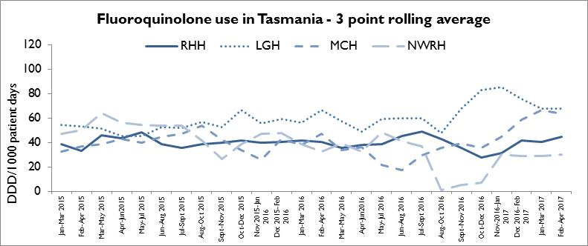
Fluoroquinolone usage in Tasmanian hospitals is the highest of all of the states as seen in the AURA 2017 report. Fluoroquinolone usage has been steady at the RHH and the NWRH with the most recent usage being approximately 45 DDD per1000 patient days and 30 DDD per1000 patient days respectively. At the MCH, the usage has significantly increased over the last 12 months, with most recent usage data being approximately 64 DDD per1000 patient days, nearly three times the usage when compared with late 2016. At the LGH, there was a significant increase in usage to 85 DDD per 1000 patient days in early 2017, but there has been with a subsequent reduction in usage with the most recent usage being 67 DDD per1000 patient days.
Figure 25 Piperacillin - tazobactam use
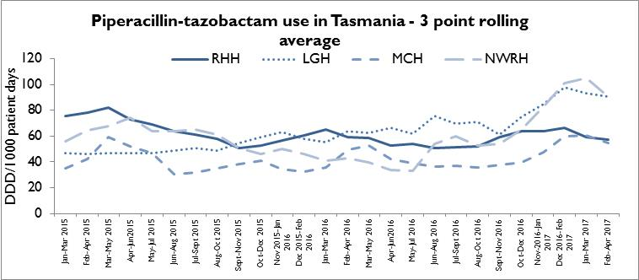
Piperacillin-tazobactam usage has been steady at the RHH and the MCH with the most recent usage being approximately 57 DDD per1000 patient days and 55 DDD per1000 patient days respectively. At the NWRH and the LGH, the usage has significantly increased over the last 12 months, with most recent usage data being approximately 90 DDD per1000 patient days at each of these hospitals.
Figure 26 Vancomycin use
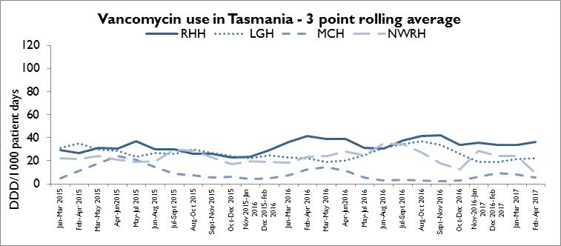
Vancomycin use has generally reduced across all 4 public hospitals over the last 12 months with the RHH using the highest DDD per1000 bed days with the most recent usage data being 36 DDD per1000 patient days.

Acknowledgements
The production of this report is the culmination of data collection, analysis and input from a number of different organisations. In particular, we would like to acknowledge:
- Executive Director of Nursing THS North
- Executive Director of Nursing THS North West
- Executive Director of Nursing THS South
- Launceston General Hospital Infection Prevention and Control Unit
- North West Regional Hospital Infection Control Team
- Mersey Community Hospital Infection Control Team
- Royal Hobart Hospital Infection Prevention and Control Unit
- Microbiology Departments at the Royal Hobart Hospital, Launceston General Hospital and DSPL
- Hand Hygiene Australia
- Communicable Diseases Prevention Unit, Public Health Services
- Contributing Primary Health Sites

Appendix 1

Explanatory notes

What types of healthcare surveillance are done in Tasmania?
TIPCU undertakes surveillance of the following:
- Staphylococcus aureus bacteraemia (bloodstream infection).
- Clostridium difficile infection (CDI).
- Vancomycin resistant enterococci (VRE).
- Hand hygiene compliance rates.
- Antibiotic utilisation.

What do the rates mean?
The healthcare surveillance data are expressed as a rate or a raw number. SAB and CDI are expressed as a rate per 10 000 patient days, VRE is expressed as a raw number, hand hygiene compliance is expressed as a percentage and antibiotic utilisation is expressed as hospital use measured by defined daily doses, per 1 000 occupied bed days.

What are the definitions for Clostridium difficile infection (CDI)?
TIPCU use the national surveillance definitions published by the Australian Commission on Safety and Quality in Health Care (ACSQHC) to classify CDI. TIPCU reports on:
- Hospital identified CDI is defined as a case diagnosed in a patient attending an acute care facility. This includes positive specimens obtained from admitted patients and those attending the emergency department and outpatient departments. This definition excludes patients less than two years old and cases with a positive test within the previous eight weeks.
- Healthcare associated – healthcare facility onset CDI (HCA-HCF CDI) is defined as a patient with CDI symptom onset (or date and time of stool specimen collection if a laboratory system is used) more than 48 hours after admission to a healthcare facility. This definition excludes patients less than two years old and cases with a positive test within the previous eight weeks.

What are the definitions for healthcare associated Staphylococcus aureus bacteraemia (SAB)?
Criterion A the patient’s first SAB blood culture was collected more than 48 hours after hospital admission or less than 48 hours after discharge.
OR
Criterion B the patient’s first positive SAB blood culture was collected less than or equal to 48 hours after hospital admission and one or more of the following key clinical criteria was met for the patient-episode of SAB.
Key clinical criteria:
- SAB is a complication of the presence of an indwelling medical device (eg intravascular line, haemodialysis vascular access, CSF shunt, urinary catheter).
- SAB occurs within 30 days of a surgical procedure or 365 days for surgically implanted devices, where the SAB is related to the surgical site.
- SAB was diagnosed within 48 hours of a related invasive instrumentation or incision.
- SAB is associated with neutropenia (less 1 x 10⁹/L) contributed to by cytotoxic therapy.
What are the definitions for vancomycin resistant enterococci (VRE)?
The definition for VRE is an isolate identified as VRE by an accredited laboratory. TIPCU reports on the total number of people with new isolates of VRE identified in Tasmania per quarter and this number includes all people with new VRE isolates from public and private hospitals, rural hospitals, GP clinics and long term and residential care facilities.

Confidence intervals
Confidence intervals are used to calculate the range in which the true rate probably lies. As an example, when looking at the hand hygiene compliance (HHC) data “confidence intervals calculate the range in which the true compliance result lies, based on the data collected and the compliance measured, thus providing an indication of the reliability of the reported HHC level.
When only a small number of moments are collected, the confidence interval will be larger, as it is more difficult to establish the true compliance level from a small sample of moments.
If a large number of moments are collected the confidence interval will be smaller, meaning the reliability of the result is higher. Hand Hygiene Australia (HHA) calculates 95 per cent confidence intervals, indicating the intervals in which 95 per cent of the time the true compliance level lies.” (HHA 2011)
Patient care days
Patient days is the term to explain the total days patients are in hospital. In each of Tasmania’s four larger acute public hospitals there are around 330 000 patient care days a year.
When a rate is presented as a number per 10 000 patient days this presents the number of infections that occur for every 10 000 patient care days.

Can I compare Tasmanian hospital infection rates?
Each Tasmanian hospital provides different services and has patients with different levels of illness.
This affects infection rates. For example, very sick immuno-compromised patients may be more likely to get infections. It is difficult to remove all of the factors outside the control of a hospital that can cause its infection rate to differ from other hospitals.
Other reasons for caution when comparing hospitals include:
- some hospitals may screen patients more than others. This can affect data for CDI and VRE in particular
- hospital laboratories may use different ways of identifying organisms. A laboratory that has a more sensitive way of looking for organisms may find more
- for hand hygiene, rural hospitals are not required to collect as many moments as the four acute public hospitals, so comparisons between rural and acute hospitals are not recommended.

Appendix 2

Healthcare associated Staphylococcus aureus bacteraemia (SAB)
Table 3 Tasmanian numbers and rate per 10 000 patient days of HCA-SAB.
Quarter | Total HCA-SAB | Number MSSA | Number MRSA | HCA SAB Rate
Q1 2012 | 7 | 6 | 1 | 0.9
Q2 2012 | 7 | 6 | 1 | 0.9
Q3 2012 | 6 | 6 | 0 | 0.7
Q4 2012 | 10 | 9 | 1 | 1.3
Q1 2013 | 7 | 7 | 0 | 0.9
Q2 2013 | 8 | 7 | 1 | 0.9
Q3 2013 | 6 | 6 | 0 | 0.7
Q4 2013 | 7 | 7 | 0 | 0.8
Q1 2014 | 10 | 9 | 1 | 1.2
Q2 2014 | 12 | 10 | 2 | 1.4
Q3 2014 | 6 | 6 | 0 | 0.7
Q4 2014 | 4 | 4 | 0 | 0.5
Q1 2015 | 10 | 9 | 1 | 1.2
Q2 2015 | 9 | 7 | 2 | 1.0
Q3 2015 | 12 | 10 | 2 | 1.4
Q4 2015 | 5 | 4 | 1 | 0.6
Q1 2016 | 8 | 6 | 2 | 1.0
Q2 2016 | 11 | 10 | 1 | 1.2
Q3 2016 | 7 | 7 | 0 | 0.8
Q4 2016 | 12 | 11 | 1 | 1.4
Q1 2017 | 7 | 6 | 1 | 0.8
Q2 2017 | 12 | 10 | 2 | 1.3

Table 4 Royal Hobart Hospital numbers and rates per10 000 patient days of HCA-SAB
Quarter | Total HCA-SAB | Number MSSA | Number MRSA | HCA SAB Rate
Q1 2012 | 2 | 2 | 0 | 0.5
Q2 2012 | 3 | 3 | 0 | 0.8
Q3 2012 | 3 | 3 | 0 | 0.8
Q4 2012 | 4 | 4 | 0 | 1.1
Q1 2013 | 2 | 2 | 0 | 0.6
Q2 2013 | 4 | 4 | 0 | 0.9
Q3 2013 | 2 | 2 | 0 | 0.5
Q4 2013 | 4 | 4 | 0 | 1.0
Q1 2014 | 3 | 3 | 0 | 0.8
Q2 2014 | 5 | 4 | 1 | 1.3
Q3 2014 | 1 | 1 | 0 | 0.3
Q4 2014 | 1 | 0 | 0 | 0.3
Q1 2015 | 3 | 2 | 1 | 0.8
Q2 2015 | 4 | 4 | 0 | 1.0
Q3 2015 | 5 | 5 | 0 | 1.3
Q4 2015 | 2 | 2 | 0 | 0.5
Q1 2016 | 2 | 2 | 0 | 0.5
Q2 2016 | 4 | 4 | 0 | 1.0
Q3 2016 | 3 | 3 | 0 | 0.8
Q4 2016 | 7 | 7 | 0 | 1.8
Q1 2017 | 3 | 2 | 1 | 0.8
Q2 2017 | 5 | 5 | 0 | 1.2
Table 5 Launceston General Hospital numbers and rates per10 000 patient days of HCA-SAB
Quarter | Total HCA-SAB | Number MSSA | Number MRSA | HCA SAB Rate
Q1 2012 | 2 | 1 | 1 | 0.8
Q2 2012 | 2 | 2 | 0 | 0.8
Q3 2012 | 2 | 2 | 0 | 0.7
Q4 2012 | 6 | 5 | 1 | 2.3
Q1 2013 | 4 | 4 | 0 | 1.5
Q2 2013 | 4 | 3 | 1 | 1.3
Q3 2013 | 3 | 3 | 0 | 1.0
Q4 2013 | 3 | 3 | 0 | 1.0
Q1 2014 | 4 | 4 | 0 | 1.4
Q2 2014 | 3 | 2 | 1 | 1.0
Q3 2014 | 2 | 2 | 0 | 0.6
Q4 2014 | 2 | 2 | 0 | 0.7
Q1 2015 | 5 | 5 | 0 | 1.6
Q2 2015 | 4 | 2 | 2 | 1.3
Q3 2015 | 5 | 3 | 2 | 1.5
Q4 2015 | 2 | 1 | 1 | 0.6
Q1 2016 | 5 | 3 | 2 | 1.6
Q2 2016 | 4 | 4 | 0 | 1.2
Q3 2016 | 2 | 2 | 0 | 0.6
Q4 2016 | 1 | 0 | 1 | 0.3
Q1 2017 | 3 | 3 | 0 | 0.9
Q2 2017 | 5 | 3 | 2 | 1.4
Table 6 Mersey Community Hospital numbers and rates per10 000 patient days of HCA-SAB
Quarter | Total HCA-SAB | Number MSSA | Number MRSA | HCA SAB Rate
Q1 2012 | 1 | 1 | 0 | 1.9
Q2 2012 | 1 | 1 | 0 | 1.7
Q3 2012 | 1 | 1 | 0 | 1.6
Q4 2012 | 0 | 0 | 0 | 0.0
Q1 2013 | 0 | 0 | 0 | 0.0
Q2 2013 | 0 | 0 | 0 | 0.0
Q3 2013 | 0 | 0 | 0 | 0.0
Q4 2013 | 0 | 0 | 0 | 0.0
Q1 2014 | 2 | 2 | 0 | 3.9
Q2 2014 | 0 | 0 | 0 | 0.0
Q3 2014 | 2 | 2 | 0 | 3.2
Q4 2014 | 1 | 1 | 0 | 1.7
Q1 2015 | 1 | 1 | 0 | 1.7
Q2 2015 | 0 | 0 | 0 | 0.0
Q3 2015 | 1 | 1 | 0 | 1.5
Q4 2015 | 1 | 1 | 0 | 1.7
Q1 2016 | 1 | 1 | 0 | 2.0
Q2 2016 | 1 | 1 | 0 | 1.7
Q3 2016 | 0 | 0 | 0 | 0.0
Q4 2016 | 3 | 3 | 0 | 6.2
Q1 2017 | 0 | 0 | 0 | 0.0
Q2 2017 | 1 | 1 | 0 | 2.3
Table 7 North West Regional Hospital numbers and rates per10 000 patient days of HCA-SAB.
Quarter | Total HCA-SAB | Number MSSA | Number MRSA | HCA SAB Rate
Q1 2012 | 2 | 2 | 0 | 2.6
Q2 2012 | 1 | 0 | 1 | 1.3
Q3 2012 | 0 | 0 | 0 | 0.0
Q4 2012 | 0 | 0 | 0 | 0.0
Q1 2013 | 1 | 1 | 0 | 1.2
Q2 2013 | 0 | 0 | 0 | 0.0
Q3 2013 | 1 | 1 | 0 | 1.1
Q4 2013 | 0 | 0 | 0 | 0.0
Q1 2014 | 1 | 0 | 1 | 1.2
Q2 2014 | 4 | 4 | 0 | 3.7
Q3 2014 | 1 | 1 | 0 | 1.0
Q4 2014 | 0 | 0 | 0 | 0.0
Q1 2015 | 1 | 1 | 0 | 1.0
Q2 2015 | 1 | 1 | 0 | 0.9
Q3 2015 | 1 | 1 | 0 | 0.9
Q4 2015 | 0 | 0 | 0 | 0.0
Q1 2016 | 0 | 0 | 0 | 0.0
Q2 2016 | 2 | 1 | 1 | 1.8
Q3 2016 | 2 | 2 | 0 | 1.8
Q4 2016 | 1 | 1 | 0 | 0.9
Q1 2017 | 1 | 1 | 0 | 1.0
Q2 2017 | 1 | 1 | 0 | 0.9

Clostridium difficile infection (CDI)
Table 8 Tasmanian numbers and rates per10 000 patient days of CDI
Quarter | Total hospital identified CDI | Hospital identified Rate | Total HCA HCF | HCA HCF Rate
Q1 2012 | 50 | 7.1 | 24 | 3.4
Q2 2012 | 43 | 6.0 | 26 | 3.6
Q3 2012 | 39 | 5.1 | 18 | 2.4
Q4 2012 | 45 | 6.2 | 26 | 3.6
Q1 2013 | 50 | 7.1 | 31 | 4.4
Q2 2013 | 57 | 7.5 | 27 | 3.6
Q3 2013 | 55 | 6.9 | 31 | 3.9
Q4 2013 | 42 | 5.4 | 16 | 2.1
Q1 2014 | 47 | 6.3 | 23 | 3.1
Q2 2014 | 27 | 3.5 | 13 | 1.7
Q3 2014 | 27 | 3.4 | 15 | 1.9
Q4 2014 | 38 | 4.8 | 21 | 2.7
Q1 2015 | 36 | 4.7 | 16 | 2.1
Q2 2015 | 37 | 4.6 | 19 | 2.3
Q3 2015 | 43 | 5.2 | 21 | 2.6
Q4 2015 | 43 | 5.3 | 22 | 2.7
Q1 2016 | 35 | 4.5 | 12 | 1.5
Q2 2016 | 45 | 5.5 | 17 | 2.1
Q3 2016 | 40 | 4.8 | 20 | 2.4
Q4 2016 | 34 | 4.2 | 12 | 1.5
Q1 2017 | 40 | 5.0 | 23 | 2.9
Q2 2017 | 52 | 6.1 | 25 | 2.9

Table 9 Hospital numbers and rates per10 000 patient days of hospital identified CDI
Quarter | Royal Hobart |  | Launceston General |  | Mersey Community |  | NW Regional
 | Total | Rate | Total | Rate | Total | Rate | Total | Rate
Q1 2012 | 32 | 9.4 | 13 | 5.5 | 2 | 4.0 | 3 | 3.9
Q2 2012 | 23 | 6.7 | 12 | 5.0 | 4 | 7.3 | 4 | 5.2
Q3 2012 | 24 | 6.6 | 6 | 2.4 | 3 | 5.1 | 6 | 7.3
Q4 2012 | 24 | 6.9 | 7 | 2.8 | 4 | 7.9 | 10 | 12.3
Q1 2013 | 31 | 9.4 | 8 | 3.3 | 4 | 7.7 | 7 | 8.6
Q2 2013 | 32 | 8.7 | 9 | 3.4 | 5 | 9.8 | 11 | 13.2
Q3 2013 | 34 | 9.1 | 6 | 2.1 | 4 | 7.0 | 11 | 12.5
Q4 2013 | 25 | 6.8 | 7 | 2.6 | 4 | 7.3 | 6 | 7.3
Q1 2014 | 22 | 6.4 | 8 | 2.9 | 6 | 12.5 | 11 | 13.2
Q2 2014 | 11 | 3.2 | 6 | 2.1 | 4 | 7.3 | 6 | 6.1
Q3 2014 | 16 | 4.5 | 5 | 1.7 | 2 | 3.4 | 6 | 6.2
Q4 2014 | 24 | 6.9 | 4 | 1.4 | 4 | 7.1 | 6 | 5.9
Q1 2015 | 24 | 7.4 | 5 | 1.7 | 2 | 3.6 | 5 | 5.3
Q2 2015 | 27 | 7.5 | 6 | 2.0 | 1 | 1.8 | 3 | 3.0
Q3 2015 | 29 | 8.2 | 3 | 1.0 | 4 | 6.5 | 7 | 7.0
Q4 2015 | 30 | 8.5 | 2 | 0.7 | 1 | 1.8 | 10 | 10.6
Q1 2016 | 23 | 6.9 | 5 | 1.6 | 2 | 4.2 | 5 | 5.3
Q2 2016 | 22 | 6.2 | 14 | 4.6 | 5 | 9.2 | 4 | 3.9
Q3 2016 | 18 | 5.0 | 14 | 4.4 | 3 | 5.5 | 5 | 4.9
Q4 2016 | 16 | 4.5 | 8 | 2.6 | 4 | 8.6 | 6 | 5.9
Q1 2017 | 18 | 5.1 | 15 | 4.8 | 3 | 7.0 | 4 | 4.2
Q2 2017 | 25 | 6.6 | 11 | 3.3 | 3 | 6.8 | 13 | 12.3

Table 10 Hospital numbers and rates per10 000 patient days of HCA-HCF CDI
Quarter | Royal Hobart |  | Launceston General |  | Mersey Community |  | NW Regional
 | Total | Rate | Total | Rate | Total | Rate | Total | Rate
Q1 2012 | 18 | 5.3 | 5 | 2.1 | 0 | 0.0 | 1 | 1.3
Q2 2012 | 16 | 4.7 | 6 | 2.5 | 2 | 3.6 | 2 | 2.6
Q3 2012 | 12 | 3.3 | 3 | 1.2 | 1 | 1.7 | 2 | 2.4
Q4 2012 | 18 | 5.2 | 3 | 1.2 | 1 | 2.0 | 4 | 4.9
Q1 2013 | 24 | 7.2 | 5 | 2.1 | 1 | 1.9 | 1 | 1.2
Q2 2013 | 16 | 4.4 | 5 | 1.9 | 3 | 5.9 | 3 | 3.6
Q3 2013 | 22 | 5.9 | 1 | 0.4 | 2 | 3.5 | 6 | 6.8
Q4 2013 | 12 | 3.2 | 4 | 1.5 | 0 | 0.0 | 0 | 0.0
Q1 2014 | 13 | 3.8 | 4 | 1.4 | 2 | 4.2 | 4 | 4.8
Q2 2014 | 7 | 2.0 | 2 | 0.7 | 1 | 1.8 | 3 | 3.1
Q3 2014 | 9 | 2.5 | 3 | 1.0 | 0 | 0.0 | 3 | 3.1
Q4 2014 | 17 | 4.9 | 2 | 0.7 | 2 | 3.5 | 0 | 0.0
Q1 2015 | 10 | 3.1 | 3 | 1.0 | 2 | 3.6 | 1 | 1.1
Q2 2015 | 15 | 4.2 | 2 | 0.7 | 1 | 1.8 | 1 | 1.0
Q3 2015 | 16 | 4.5 | 2 | 0.7 | 0 | 0.0 | 3 | 3.0
Q4 2015 | 16 | 4.5 | 2 | 0.7 | 1 | 1.8 | 3 | 3.2
Q1 2016 | 11 | 3.3 | 1 | 0.3 | 0 | 0.0 | 0 | 0.0
Q2 2016 | 14 | 3.9 | 10 | 3.3 | 3 | 5.5 | 0 | 0.0
Q3 2016 | 11 | 3.0 | 5 | 1.6 | 1 | 1.8 | 3 | 3.0
Q4 2016 | 9 | 2.5 | 2 | 0.7 | 1 | 2.1 | 0 | 0.0
Q1 2017 | 12 | 3.4 | 7 | 2.2 | 2 | 4.7 | 2 | 2.1
Q2 2017 | 16 | 4.2 | 5 | 1.5 | 1 | 2.3 | 3 | 2.8

Vancomycin resistant enterococci (VRE)
Table 11 First VRE isolates identified per quarter within a) acute public hospitals, b) other healthcare settings (private hospitals, rural hospitals, GP clinics and long term and residential care facilities) and c) total Tasmanian isolates.

 | RHH | LGH | MCH | NWRH | Other healthcare settings | TOTAL
Q1 2012 | 3 | 2 | 2 | 2 | 1 | 10
Q2 2012 | 4 | 2 | 0 | 1 | 0 | 7
Q3 2012 | 3 | 2 | 2 | 0 | 1 | 8
Q4 2012 | 1 | 7 | 1 | 1 | 2 | 12
Q1 2013 | 13 | 0 | 3 | 0 | 2 | 18
Q2 2013 | 8 | 3 | 0 | 1 | 3 | 15
Q3 2013 | 8 | 1 | 0 | 2 | 1 | 12
Q4 2013 | 5 | 3 | 0 | 3 | 5 | 6
Q1 2014 | 5 | 0 | 1 | 13 | 1 | 8
Q2 2014 | 3 | 6 | 1 | 1 | 2 | 13
Q3 2014 | 1 | 2 | 3 | 2 | 0 | 8
Q4 2014 | 1 | 5 | 1 | 5 | 7 | 19
Q1 2015 | 10 | 12 | 2 | 5 | 7 | 36
Q2 2015 | 5 | 13 | 2 | 1 | 8 | 29
Q3 2015 | 33 | 17 | 9 | 5 | 19 | 83
Q4 2015 | 36 | 22 | 0 | 11 | 13 | 82
Q1 2016 | 28 | 26 | 7 | 4 | 8 | 73
Q2 2016 | 51 | 48 | 12 | 14 | 12 | 138
Q3 2016 | 30 | 65 | 8 | 23 | 28 | 154
Q4 2016 | 51 | 67 | 5 | 15 | 26 | 164
Q1 2017 | 41 | 82 | 12 | 13 | 26 | 174
Q2 2017 | 70 | 78 | 9 | 12 | 28 | 197

Table 12 Classification of first VRE isolates – by specimen type
Quarter | Total VRE | Screening specimens | Clinical specimens
Q1 2012 | 10 | 8 | 2
Q2 2012 | 7 | 7 | 0
Q3 2012 | 8 | 8 | 0
Q4 2012 | 12 | 9 | 3
Q1 2013 | 18 | 17 | 1
Q2 2013 | 15 | 13 | 2
Q3 2013 | 12 | 10 | 2
Q4 2013 | 16 | 14 | 2
Q1 2014 | 8 | 6 | 2
Q2 2014 | 13 | 11 | 2
Q3 2014 | 8 | 8 | 0
Q4 2014 | 19 | 19 | 0
Q1 2015 | 36 | 27 | 9
Q2 2015 | 29 | 16 | 13
Q3 2015 | 83 | 72 | 11
Q4 2015 | 82 | 70 | 12
Q1 2016 | 73 | 65 | 8
Q2 2016 | 138 | 125 | 13
Q3 2016 | 154 | 136 | 18
Q4 2016 | 164 | 145 | 19
Q1 2017 | 174 | 160 | 14
Q2 2017 | 197 | 185 | 12

Table 13 Classification of first VRE isolates – colonisation and infection
Quarter | Total VRE | Colonisation | Infection | % infection
Q1 2012 | 10 | 8 | 2 | 20%
Q2 2012 | 7 | 7 | 0 | 0%
Q3 2012 | 8 | 8 | 0 | 0%
Q4 2012 | 12 | 9 | 3 | 25%
Q1 2013 | 18 | 18 | 0 | 0%
Q2 2013 | 15 | 13 | 2 | 13%
Q3 2013 | 12 | 11 | 1 | 8%
Q4 2013 | 16 | 16 | 0 | 0%
Q1 2014 | 8 | 7 | 1 | 13%
Q2 2014 | 13 | 13 | 0 | 0%
Q3 2014 | 8 | 8 | 0 | 0%
Q4 2014 | 19 | 19 | 0 | 0%
Q1 2015 | 36 | 29 | 7 | 19%
Q2 2015 | 29 | 18 | 11 | 38%
Q3 2015 | 83 | 77 | 6 | 7%
Q4 2015* | 82 | 76 | 3 | 4%
Q1 2016 | 73 | 71 | 2 | 3%
Q2 2016 | 138 | 134 | 4 | 3%
Q3 2016 | 154 | 147 | 17 | 5%
Q4 2016 | 164 | 158 | 6 | 4%
Q1 2017 | 174 | 169 | 5 | 3%
Q2 2017 | 197 | 196 | 1 | 1%
* 3 specimens unknown if represented colonisation or infection.

Table 14 First VRE isolates by genotype by quarter
Quarter | VAN A | VAN B | VAN A and B | Unknown
Q1 2012 | 2 | 7 | 1 | 0
Q2 2012 | 2 | 5 | 0 | 0
Q3 2012 | 1 | 7 | 0 | 0
Q4 2012 | 1 | 10 | 0 | 1
Q1 2013 | 0 | 18 | 0 | 0
Q2 2013 | 1 | 14 | 0 | 0
Q3 2013 | 0 | 12 | 0 | 0
Q4 2013 | 0 | 16 | 0 | 0
Q1 2014 | 1 | 7 | 0 | 0
Q2 2014 | 1 | 11 | 0 | 1
Q3 2014 | 0 | 8 | 0 | 0
Q4 2014 | 2 | 17 | 0 | 0
Q1 2015 | 3 | 33 | 0 | 0
Q2 2015 | 2 | 27 | 0 | 0
Q3 2015 | 3 | 78 | 0 | 2
Q4 2015* | 2 | 80 | 0 | 0
Q1 2016 | 10 | 61 | 1 | 1
Q2 2016 | 14 | 120 | 2 | 2
Q3 2016 | 55 | 93 | 4 | 2
Q4 2016 | 46 | 111 | 7 | 0
Q1 2017 | 47 | 119 | 4 | 1
Q2 2017 | 31 | 164 | 1 | 1

Hand hygiene compliance data June 2017
Table 15 Hand hygiene compliance rates by Tasmanian hospital and state level
Hospital Name | HH Correctly Performed | HH Moments | Compliance | Lower 95% confidence interval | Upper 95% confidence interval
Royal Hobart | 2116 | 2691 | 79% | 77% | 80%
LGH | 4114 | 5047 | 82% | 80% | 83%
Mersey | 543 | 667 | 81% | 78% | 84%
NWRH | 824 | 1042 | 79% | 77% | 81%
Midlands MPC | 43 | 66 | 65% | 53% | 76%
New Norfolk | 51 | 57 | 89% | 79% | 95%
Beaconsfield | 50 | 60 | 83% | 72% | 91%
Campbell Town | 55 | 62 | 89% | 78% | 94%
Deloraine | 145 | 158 | 92% | 86% | 95%
Flinders Is. MPC | 56 | 79 | 71% | 60% | 80%
George Town | 39 | 54 | 72% | 59% | 82%
NESM Scottsdale | 64 | 70 | 91% | 83% | 96%
St Helens | 40 | 61 | 66% | 53% | 76%
St Marys CHC | 99 | 114 | 87% | 79% | 92%
King Island | 68 | 81 | 84% | 74% | 90%
Smithton | 57 | 64 | 89% | 79% | 95%
Healthwest | 42 | 58 | 72% | 60% | 82%
TOTAL | 8406 | 10431 | 80.6% | 80% | 81%

Table 16 Tasmanian hand hygiene compliance rates by moment
Moments | HH Correctly Performed | Total HH Moments | Compliance | Lower 95% confidence interval | Upper 95% confidence interval
Moment 1 | 2235 | 2909 | 77% | 75% | 78%
Moment 2 | 554 | 769 | 72% | 69% | 75%
Moment 3 | 943 | 1084 | 87% | 85% | 89%
Moment 4 | 2705 | 3127 | 87% | 85% | 88%
Moment 5 | 1969 | 2742 | 77% | 76% | 79%
TOTAL | 8406 | 10431 | 81% | 80% | 81%

Table 17 Tasmanian hand hygiene compliance rates by healthcare worker
Staff Type | HH Correctly Performed | HH Moments | Compliance | Lower 95% confidence interval | Upper 95% confidence interval
Clerical | 14 | 24 | 58% | 39% | 76%
Allied Health | 326 | 399 | 82% | 78% | 85%
Domestic | 146 | 215 | 68% | 61% | 74%
Invasive Technician | 69 | 88 | 78% | 69% | 86%
Doctor | 689 | 1063 | 65% | 62% | 68%
Nurse/Midwife | 6389 | 7685 | 83% | 82% | 84%
Other | 26 | 45 | 58% | 43% | 71%
Personal care staff | 369 | 456 | 81% | 77% | 84%
Student Doctor | 38 | 54 | 70% | 57% | 81%
Student Nurse/Midwife | 338 | 399 | 85% | 81% | 88%
Student Allied Health | 1 | 1 | 100% | 21% | 100%
Ambulance worker | 1 | 2 | 50% | 9% | 91%
TOTAL | 8406 | 10431 | 81% | 81% | 81%

