**Version 1.0**

**29 September 2017**

Contents

1 Executive Summary 3

1.1 Background 3

1.2 Methodology 3

1.3 Results 3

1.4 Conclusions 3

2 Principles and Strategic Priorities 4

3 Multimorbidity 5

4 Methodology 10

4.1 Data Specification 10

4.2 Chronic Conditions List 10

4.3 Data extraction and exclusions 10

4.4 Data Analysis 11

5 Results 18

5.1 Descriptive statistics 18

5.2 Linear regression analysis 19

6 Morbidity Profile Visualisation 22

7 Service Planning 25

7.1 Which shared conditions should we focus on in Tasmania? 25

7.2 What are the options for responding to multimorbidity? 25

7.3 Future development 26

8 Appendices 27

9 Bibliography 37

1. Executive Summary
   1. **Background**

The ongoing evolution of our population demographic, driven in part by increasing life expectancy and in part declining fertility rates, has resulted in the proportion of older people in our population increasing. This trend is common across most developed countries.

Developed countries have high prevalence rates of multimorbidity. Multimorbid patients have high rates of service utilisation, complications, longer hospital stays and higher cost to the health system.

In order to develop an adequate policy framework for multimorbid patients, a robust methodology is required to describe and compare multimorbidity either between geographical regions or longitudinally over time. Part of this methodology is the development of a chronic disease listing and associated ICD10 map that allows for standardised data extraction and subsequent comparison.

* 1. **Methodology**

An initial literature scan was undertaken searching for multimorbidity studies which contained listings of chronic conditions and ICD10 codes. Fourteen published journal articles were identified and included as an initial chronic condition listing.

Data was extracted from the acute inpatient coded data for two years with a number of filters applied post extraction. A novel mix of standard statistical methods and social network analysis is proposed as a means to create and compare morbidity profiles. Odds Ratios are calculated between shared conditions to ascertain the strength of effect. These are subsequently translated into a network graph in order to visualise the network. Linear regression using the odds ratios is utilised to determine the degree of similarity between morbidity profiles.

* 1. **Results**

Linear regression indicated that there is no significant difference between the Tasmanian regions: North and South, and Statewide morbidity profiles. Thus the Statewide profile was used for further analysis and conclusions.

* 1. **Conclusions**

The following conditions were identified as benefiting from increased collaboration:

There are three clusters of conditions. The first cluster is a large one with Musculoskeletal conditions at the centre.
Musculoskeletal conditions could be better integrated with the following five conditions. Cardiovascular disease, Endocrine conditions, Hearing and Vision, Neurological conditions and respiratory conditions.  
The second cluster consuists of Respiratory conditions which are closely related to Mental Health and Substance abuse. 
The last cluster consists of Endocrine conditions, Hearing and vision and cardiovascular conditions are also closely related.

These combinations of conditions represent those that provide the greatest burden for Tasmanians and have the strongest associations with each other across the state.

1. Principles and Strategic Priorities

The DHHS will work in accordance with the vision, principles and strategic priorities outlined in the *‘DHHS Corporate Plan 2016-18’* to keep Tasmanians safe, healthy and well.

The Tasmanian Health System Purchasing Framework figure below outlines the Purchaser Principles to support the DHHS to guide health service planning and delivery in Tasmania:

Figure 1: Tasmanian Health System Purchasing Framework

There are four levels to the framework. The first level outlines the vision which is to deliver services, policies, programs and legislation that improves the health, safety  and wellbeing of Tasmanians.
The second level down outlines the five principles underpinning the vision. Thes are Client and Community Focus. Effective Governance. Strategic Collaboration. Intelligent decision making. Leadershjip and culture. 
The third or second last layer, outlines our five strategic priorities. These are Healthy and safe Tasmanians. Wellgoverned systems. Integrated services. Evidence based services. Engaged Workforce.
The final level describes the principles  underpinning the framework. There are four of these, they are:
Targetting the health needs of Tasmanians.
Access to quality care.
Prioritisation of of access is fair and affordable.
New affordable and innovative models of care are supported.


1. Multimorbidity

A chronic condition is a condition that is present, usually for twelve months or more and requires ongoing medical attention and/or limits activities of daily living (Warshaw 2006 in Goodman et al. 2013).

The ongoing evolution of our population demographic, driven in part by increasing life expectancy and in part declining fertility rates, has resulted in the proportion of older people in our population increasing. This trend is common across most developed countries. Australia, and more specifically Tasmania, is experiencing the same trend resulting in the population profile of Tasmania changing considerably by 2050 (Figure1).

Theer are three diagrams in this picture. Each of which detail the population profile of Tasmania for three different years, 1971, 2015 and projected ut to 2050. The 1971 profile is a classic pyramidal shape, with more younger people and fewer older people. The 2015 profile starts to show more older people and fewer younger people. The 2050 profile continues this trend.

Figure 1: The changing population profile for Tasmania from 1971 to 2050 (Australian Bureau of Statistics data)

Concomitant with this trend have been improvements in the treatment regimens and management of individual chronic conditions.

This demographic evolution combined with advances in medical management has resulted in a high prevalence of people living with multiple chronic conditions (multimorbidity). There is no agreed standard definition of multimorbidity, but the most common definition is the presence of two or more chronic conditions (Marengoni et al. 2009).

It should be noted at this point, the difference between comorbidity and multimorbidity. Comorbidity refers to those conditions that “co-occur” with a reference or index disease (van den Akker, Buntinx & Knottnerus 1996). For example, conditions that commonly occur with respiratory disease or conditions that occur with cardiovascular disease. Multimorbidity on the other hand has no central reference disease. Valderas (2009) put forward this useful construct (Figure 2) to explain comorbidity, multimorbidity and patient complexity:

Comorbidity consists of s reference disease, and the other conditions that are associated with this particular condition are called comrbidities. 
Multimorbidity on the oter hand does not have a central condition but shows all conditions that are related.

Figure 2: Comorbidity and multimorbidity constructs (Valderas et al. 2009)

The number of life years spent in multimorbidity is increasing (Tetzlaff et al. 2017). This trend is occurring in many countries across the world and introduces increasing complexity (as opposed to acuity) into the treatment and management of patients.

Australian multimorbidity prevalence estimates in the primary care sector are reported between 25% (Britt et al. 2008) and 32.6% (Harrison et al. 2016). Multimorbidity increases with age with prevalence rates exceeding 60% for those over the age of sixty five (Eckardt et al. 2017).

Multimorbid patients have higher rates of health care utilisation (Wang et al. 2017), are at greater risk for further complications (Weir et al. 2015) and mortality (Le Corvoisier et al. 2015; Prior et al. 2016). Furthermore, the cost of care required by multimorbid patients is also higher (Navickas et al. 2016; Picco et al. 2016; Specogna et al. 2017). Anecdotally, complexity introduces “inefficiency” in a system that is designed around single disease care and has a multiplier effect on the care requirements of multimorbid patients. For example, in surgery, they take longer to anaesthetise, longer to operate on with a higher risk of complications and take longer to recover.

Similar findings are evident in the Tasmanian acute admitted data (DHHS-PPP-MRA, 2015) as illustrated in the below Figure 3.

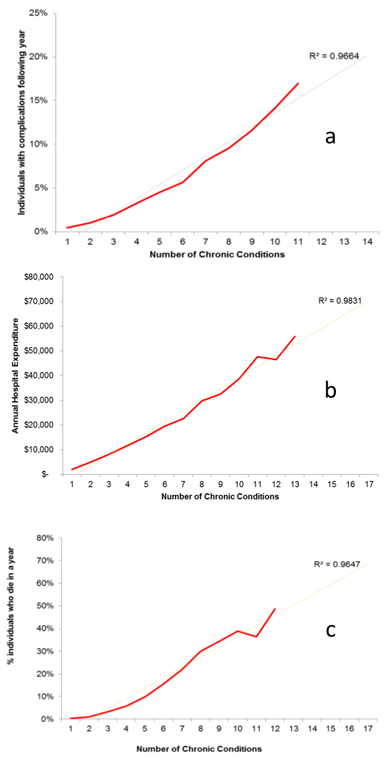

Figure 3: The relationship between the number of chronic conditions in the acute sector and (a) individuals experiencing complications, (b) annual hospital expenditure and (c) mortality (DHHS-PPP-MRA, 2015)

There are significant health care burdens (Table 1) for those that are grossly multimorbid (those identified as having six or more chronic conditions). This group of patients have more than twice as many hospital episodes as other patients, stay in hospital for longer, and are more likely to experience hospital acquired complications (HACs).

Table 1: 2015 Multimorbid vs non-multimorbid acute episodes in Tasmanian Major Hospitals (Internal DHHS analysis).

|  |  |  |
| --- | --- | --- |
|  | **<6**  **chronic conditions** | **6+**  **chronic conditions** |
| Total Persons | 50,608 | 3,904 |
| Total Episodes | 93,603 | 18,096 |
| Total Episode days | 238,512 | 61,100 |
| Episodes Average Length of Stay (days) | 2.5 | 3.4 |
| Episodes per person per annum | 1.8 | 4.6 |
| Days per person | 4.7 | 15.7 |
| Hospital Acquired Complication rate per Episode | 2.60% | 5.00% |
| Hospital Acquired Complication rate per Person | 4.80% | 23.20% |

This presents a challenge for health care systems which are designed and funded for single conditions (Harrison et al. 2016). It is more difficult for patients to navigate the system and it is more difficult for clinicians to treat and manage these patients. Across developed country health systems we are seeing a rise in health care roles that “coordinate” and “navigate” with the need for “command centres”, and also calls for Information and Communications Technology (ICT) solutions with complex workflows capabilities.

These initiatives are symptomatic of the increasing complexity in our patient population and reflect that system design, commissioning, policy and funding models have not kept pace with the evolving morbidity profile of the community. Background inefficiencies that have crept in place the delivery of health care under chronic and systemic stress.

The DHHS, as System Manager, is undertaking a body of work to address multimorbidity. The issue of multimorbidity was identified in the Statement of Purchaser Intent 2017_18 (SoPI) with the intent of expanding on this work for SoPI 18_19.

Tasmania’s high rates of lifestyle-related risk factors (refer to SoPI 2018-19 Supplementary Paper 11: *Chronic Disease Risk Factors – Research and Discussion Paper*) have contributed to Tasmania having higher rates of multimorbidity (three or more self-reported chronic conditions) than any other jurisdiction. In 2014–15, 50.3% of Tasmanians had three or more chronic conditions, increasing from 41.8% in 2011–12 (DHHS 2016).

Since then, significant work has been undertaken to progress this work to identify strategic purchasing priorities and directions for SoPI 18_19. This includes a literature scan in order to provide a standardised list of chronic conditions and ICD10 codes that can be used to identify chronic conditions within data sets. The work will identify the chronic conditions that are shared the most among multimorbid patients in Tasmania (see Section 4 - Methodology below).

It is further envisaged that the multimorbidity profiles for the Tasmanian regions will also be compiled and compared. One of the benefit of comparing such profiles is that it will guide policy, funding, governance and purchasing decisions and if necessary, regional differences. It will assist in guiding which services to connect. Further consultation and engagement with service providers will help guide how these services can be connected.

To enable this work, the DHHS has secured some Commonwealth funding via the National Partnership Agreement (NPA) “Improving Health Services in Tasmania” initiative. This funding will be used to refine the chronic conditions listing and code mapping as well as fund the development of a Complex Patients Framework.

1. Methodology

*The data used in this methodology paper is acute data. Hence the output is an acute view of the system. Further work will be undertaken to obtain primary care data in order to gain a more accurate view of the complexity along the full continuum of care within the health system.*

* 1. **Data Specification**

The following data specifications were applied for this study:

* Inclusions
  + Period – 2015/16 and 2016/17 financial years
  + Acute admissions
* Exclusions
  + Age range – under eighteen years old on 1 July 2015 (start of study period)
  + Non Tasmanian postcode
  + No chronic condition ICD10 code
  1. **Chronic Conditions List**

In order to standardise data extraction and analysis, it is necessary to have a standardised listing of chronic conditions. Many lists have been published in the literature. These are summarised in Appendix 1. In addition to a standardised listing of chronic conditions, a map of associated ICD10 codes that clearly identifies chronic conditions coded is required.

*Further work will be done to not validate, with clinical experts, the chronic condition list and the ICD10 mapping.*

* 1. **Data extraction and exclusions**

Applying the data specifications n115 643 individual patients being extracted from the original data extract, leaving 66 208 patients. This constituted 57% of the initial data extract (Figure 4).

This diagram shows the number of people in the data analysis and how many were excluded for various reasons.
A total of 115643 patient records were extracted. Of these 21051 were excluded because they were under 18 years old. 
1994 were excluded because they did not have Tasmanian postcodes.
26756 were excluded because they did not have a chronic condition diagnosis code.
This left 65842 patients or 57% of the original sample in the final analysis.

Figure 4 Summary of exclusions from analysis.

* 1. **Data Analysis**

The analysis of the data occurred in multiple stages:

###### **Stage 1 – extraction and cleaning**

#### Data extraction

Data for all hospitals was extracted using the following fields:

* URN | Date of Birth | Postcode | multiple individual ICD10 codes
* All acute episodes for the financial years 2015/16 and 2016/17

#### First round data cleansing

* Age
  + Exclude anyone under the age of 18 years old during the period of study.
  + Chronic conditions in children require further work and clinical input.
* Residence
  + Exclude all non-Tasmanian postcodes (NOT 7xxx)
  + There were some postcodes that were 7xxx postcodes but not valid postcodes, these were excluded as the patients residential addresses could not be verified.
* Diagnosis codes
  + The maximum diagnosis codes for anyone person was 156. In order to rationalise the data set, the frequency distribution of diagnosis codes was analysed (Figure 5).

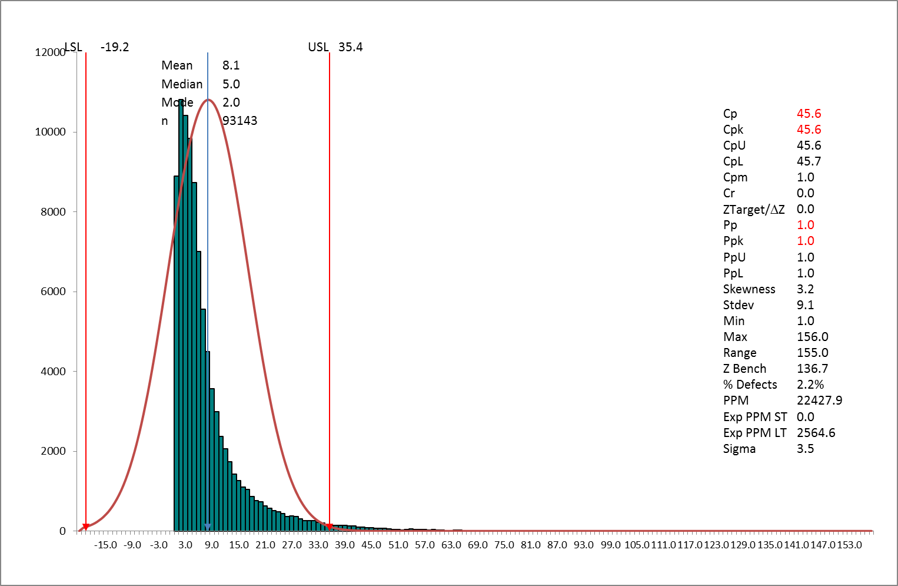

Figure 5 Frequency analysis showing cut off of diagnostic code count.

The upper control limit was determined to be 36 codes (Figure 5). All diagnosis codes beyond 36 were removed from the data.

###### **Stage 2 – mapping and cleaning**

#### Mapping of ICD10 to AIHW Groupers

This entails the mapping of Australian Institute of Health and Welfare (AIHW) Burden of Disease categories from the master mapping file to the ICD10 codes in the data. Note that extra spaces were evident in the extracted data causing errors. This was overcome by utilising the TRIM function embedded in the lookup function:

=Vlookup(TRIM(ref.cell),range, return, FALSE))

*It should be noted that at the time of writing, there were some limitations in the mapping file. Extensive work has been undertaken identifying ICD10 codes from the literature that pertain to chronic conditions. However, more work needs to be undertaken by an expert clinical panel to refine this initial work and ensure its accuracy.*

AIHW categories (groupers) were chosen for two reasons. Firstly, these align with the SoPI burden of chronic disease priorities and secondly to group the diagnosis codes into more manageable numbers for analysis purposes. In the future, it may be beneficial from a service planning perspective to utilise Service Related Groups (SRGs) as these often mirror clinical governance structures within health systems.

Mapping the ICD10 codes and an episode’s final Diagnostic Related Group (DRG) first need to be resolved. This could be overcome by using an expert panel to assign/map chronic conditions to SRGs.

#### Mapping Local Government Areas and Tasmanian Regions to postcodes

Patient postcodes are mapped to Local Government Areas (LGAs) and Tasmania Health Service regions (North and South).

#### Second round data cleansing

Further postcode errors were identified as the LGA to postcode mapping process returns any errors in Tasmanian postcodes. These patients were excluded.

###### **Stage 3 – Generate columns for edge calculation**

This is a key data transformation stage. One column per AIHW grouper is created. The header is cross matched by each patient to determine whether that grouper is present for that patient:

=MATCH(lookup grouper, in array,0)

For example =MATCH(AO$1,$E2:$AN2,0)

Note:

* Fixed row (AO$1) and fixed columns ($E2:$AN2)
* 0 means find the first value that matches the lookup grouper
* The function returns the position in the array of the lookup grouper

###### **Stage 4 – Further data cleansing and calculation of 2x2 table values for Odds Ratio calculations**

#### Third round data cleansing

* The MATCH function produces numerous #NA results where an ICD10 code in the raw data is not referenced in the mapping file i.e. that code is not listed as a chronic condition. These were removed with the FIND and REPLACE function.
* The output from the MATCH function returns a value that corresponds to the position of the lookup grouper. In order to standardise the data, these values are replaced with simple 1,0 flags:
  + =IF(cell>0,1,0)
* At this point those patients who have no chronic conditions coded can be identified by summing all rows (patients). Those patients who have a total of 0 have no chronic condition coded and are excluded from the analysis.

#### Construction of 2x2 tables

The following logic is applied in the calculation of the 2x2 table values. The creation of sets for each of the relationships between conditions within each profile occurred as follows:

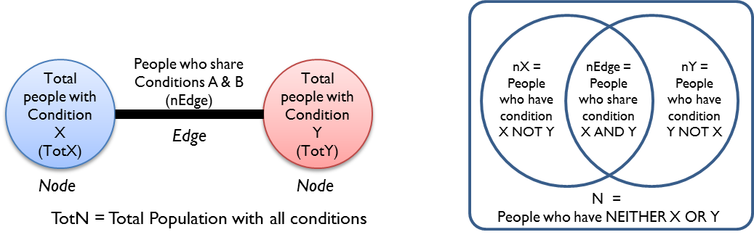

For example

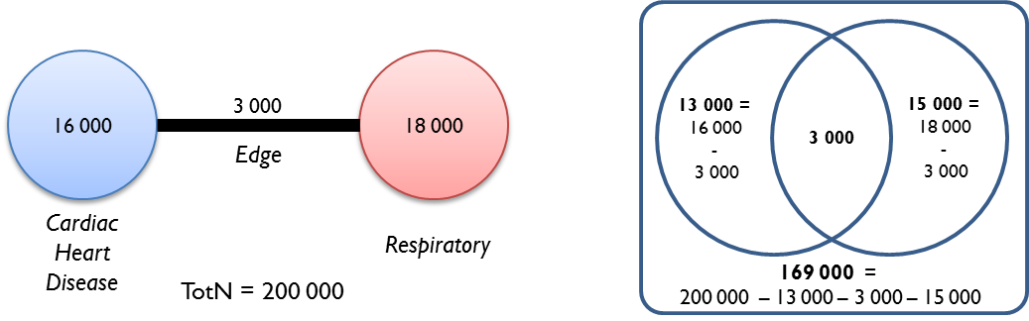

Data from each of the sets are used to populate a two by two table and calculate OR and p values (see Stage 5).

|  |  |  |  |
| --- | --- | --- | --- |
|  |  | Condition X | |
|  |  | Yes | No |
| Condition Y | Yes | nEdge | nY |
| No | nX | N |

For example:

|  |  |  |  |
| --- | --- | --- | --- |
|  |  | Cardiac Heart Disease (CHD) | |
|  |  | Yes | No |
| Respiratory  (Resp) | Yes | 3 000 | 15 000 |
| No | 13 000 | 169 000 |

#### Calculation of nEdge, nX, nY and N values

nEdge

This value is systematically calculated and noted for each combination of condition using the method outlined below. For the 15 AIHW groupers, this results in 104 edges (different combinations).

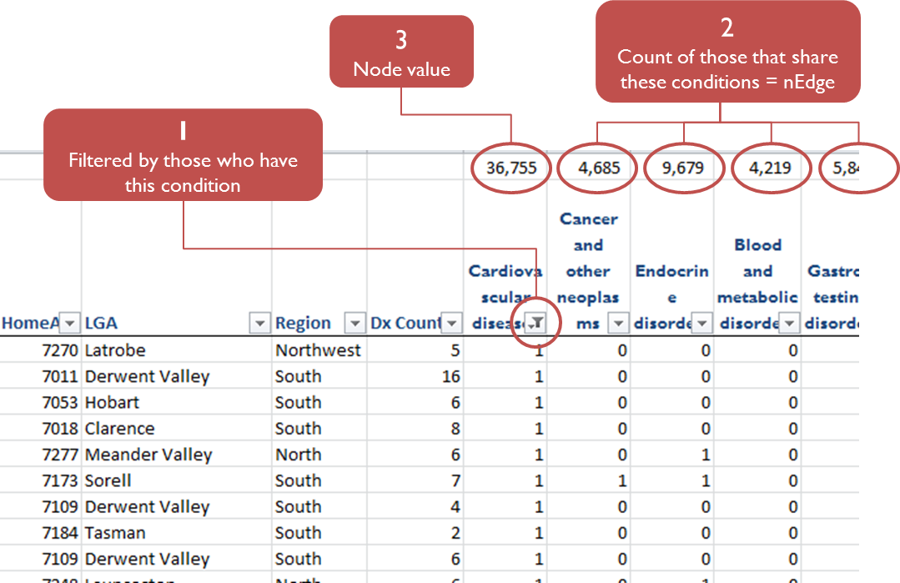

nX

nX = Node value (X) – nEdge i.e. those with only condition X and not condition Y

nY

nY = Node value (Y) – nEdge i.e. those with only condition Y and not condition X

N

N = Total sample – nEdge – nX – nY i.e. those with neither condition X nor condition Y

###### **Stage 5 – Calculation of Odds Ratios, 95% Confidence Intervals and Chi Squared p values**

In order to understand the size of the effect of shared conditions and whether that effect is significant or not, OR and Chi Squared p values are calculated. The data from Stage 5 was exported to R Statistical package. The code used to perform the calculations is shown below.

R code to compute edge Odds Ratios and Chi Squared p values

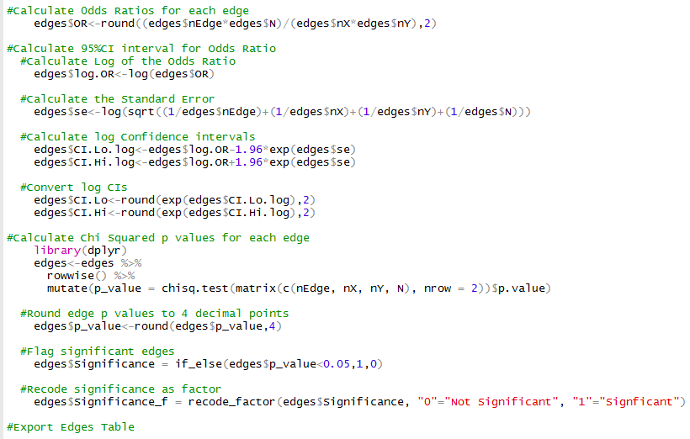

Figure 6: R code for calculating OR, p values and flagging those Odds Ratios that are significant (p<0.05).

The full output table is available in Appendix 2.

The output from this analysis is utilised in two parts in Stage 6:

1. Regression analysis is undertaken to analyse how the regions in Tasmania differ from the State profile.
2. Utilised to create a visual representation of the data in the form of a network graph.

###### **Stage 6a – Regression analysis**

*Note that Odds Ratio for these relationships will be symmetrical. Thus when applied to the edges within a social network are therefore bi directional (or non-directional).*

Odds Ratios are calculated for each of the relationships (Edges) within each profile. The R statistical package was used to generate the linear models using the following code:

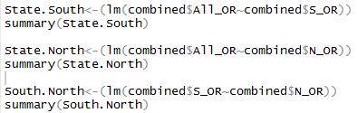

Figure 7: R code for calculating linear regression models.

Linear regression modelling was undertaken comparing the OR in the following morbidity profiles in order to ascertain how different the effects are between the regions, and the statewide profile (Figure 7):

* Statewide vs Southern region
* Statewide vs Northern region
* Southern region vs Northern region

###### **Stage 6b – Network visualisaton**

At this stage, a variety of network graphs is created utilising R (see Figure 8). Simplification of the network graph is also undertaken at this point to filter out less significant / relevant edges.

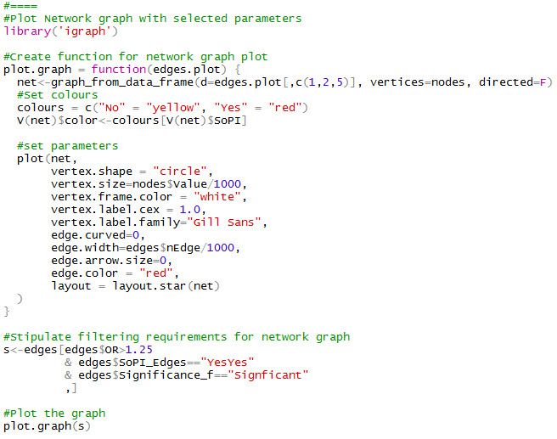

Figure 8: R code to create network graph.

1. Results
   1. **Descriptive statistics**

The age distribution of the cohort is shown below:

This is a graph of the age distribution of the patient cohort. The mean age is 60 years old. The Median is 62 years old and the Mode is 75 years old. 
The standard deviation is 19 years. The minimum age is 19 yeras and the maximum age is 103 years old. The skewness of the graph is negative 0.36.

Figure 9: Age distribution of the cohort included in the analysis.

The geographical distribution of persons, with chronic conditions, admitted to acute facilities across the state is shown below:

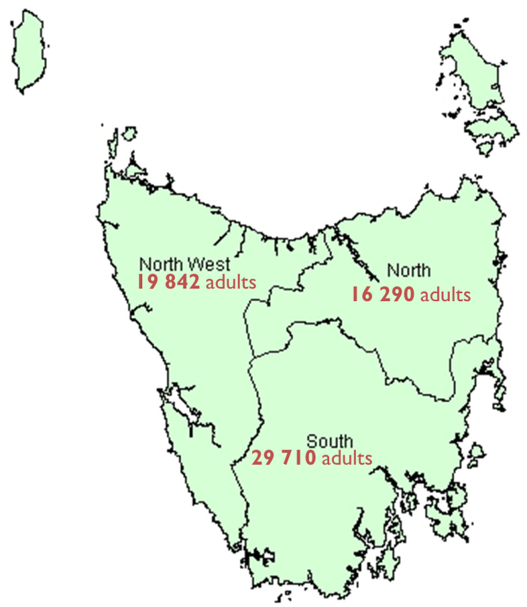

Figure 10: Cohort numbers by LGA region of people admitted to acute facilities with chronic conditions over 2015/16 and 206/17 financial years.

* 1. **Linear regression analysis**

*North and Northwest were combined to form one region (North) to mirror the governance structure of the Tasmanian Health Service (THS). See Figure 10.*

Three simple linear regression models were generated (Statewide vs Northern region, Statewide vs Southern region and Southern vs Northern region) in order to ascertain how close each of the models were and to reach a conclusion whether separate models would need to be generated for each region or whether a statewide model be used for both regions.

*The edge Neuro_Inf&Con (Neurological Conditions and Infant and Congenital Disorders) has been excluded from the regression plots due to the high Odds Ratio skewing the plots. This edge has however been included in the regression models. The values for the Neuro_Inf&Con edge are provided in the label for each figure.*

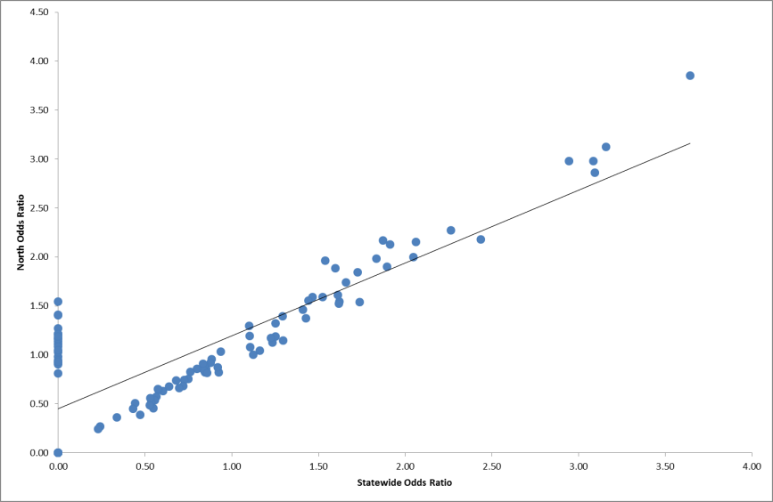

Figure 11: Scatterplot for Statewide vs Northern region. Edge *Neuro_Inf&Con* has been excluded from this plot. The OR values for the Statewide and Northern region are 13.54 and 16.95 respectively.

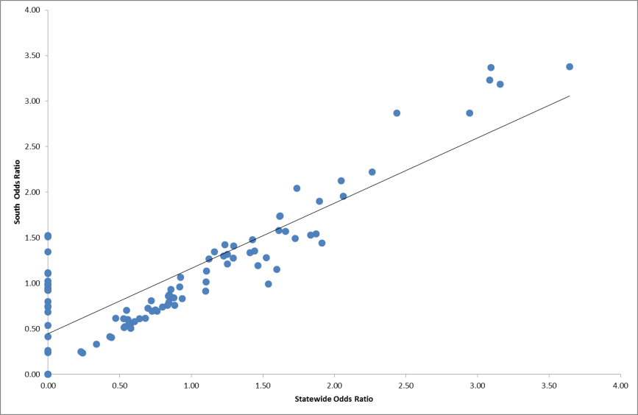

Figure 12: Scatterplot for Statewide vs Southern region. Edge *Neuro_Inf&Con* has been excluded from this plot. The OR values for the Statewide and Southern region are 13.54 and 11.87 respectively.

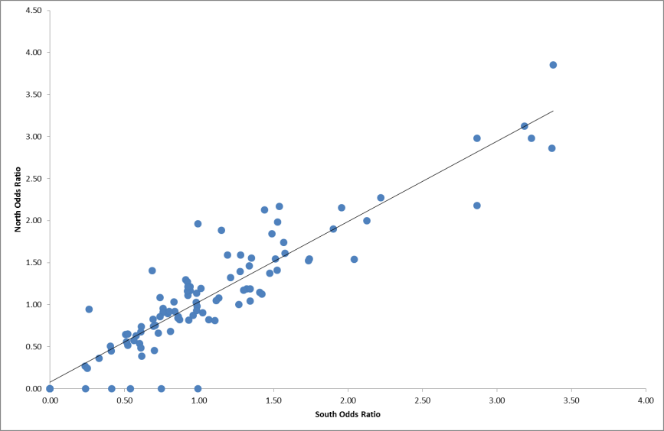

Figure 13: Scatterplot for the Southern region vs the Northern region. Edge *Neuro_Inf&Con* has been excluded from this plot. The Odds Ratio values for the Southern and northern regions are 11.87 and 16.95 respectively.

Table 2: Linear regression results for the three morbidity profile models.

|  | Intercept | Slope | Std Error | Adjusted R2 | F statistic | p |
| --- | --- | --- | --- | --- | --- | --- |
| Statewide vs  Northern region | -0.049 | 0.828 | 0.027 | 0.903 | 957.7 | 0.0000 |
| Statewide vs  Southern region | -0.323 | 1.120 | 0.036 | 0.906 | 996.6 | 0.0000 |
| Southern region vs  Northern region | 0.272 | 0.718 | 0.018 | 0.939 | 1584 | 0.0000 |

Linear regression modelling indicates that there are no significant differences between the statewide morbidity profile and the Northern and Southern morbidity profiles (Table 2). Thus it can be concluded that the statewide profile can be used to model multimorbidity across the state of Tasmania.

Based on the linear regression results, only statewide data was used to analyse and draw conclusions about the morbidity profile across the state.

1. Morbidity Profile Visualisation

Statewide edge and node data was loaded into SocNetV-2.1 and progressively refined and visualised (Figure 14 and 15).

Table 3: Network graph key (Figure 14, 15 and 16) showing DHHS Statement of Purchaser Intent (SoPI) priority and non-priority conditions.

|  |  |  |  |
| --- | --- | --- | --- |
| SoPI Priority conditions | | Non SoPI Priority conditions | |
| Ca | Cancer and neoplasms | Gast | Gastroenterological conditions |
| CVD | Cardiovascular conditions | Bl&Met | Blood and Metabolic disorders |
| End | Endocrine conditions | Renal | Renal conditions |
| H&V | Hearing and Vision conditions | Inf&Con | Infant and Congenital conditions |
| MH | Mental Health and Substance Abuse | Infect | Infectious diseases |
| mSkelet | Musculoskeletal conditions | Rep&Mat | Reproductive and Maternal conditions |
| Neuro | Neurological conditions | Skin | Skin disorders |
| Resp | Respiratory conditions |  |  |

Figure 14 shows the full morbidity profile of the state which includes both SoPI and non SoPI priority conditions. This graph includes all significant OR (See Appendix 2 for full listing).

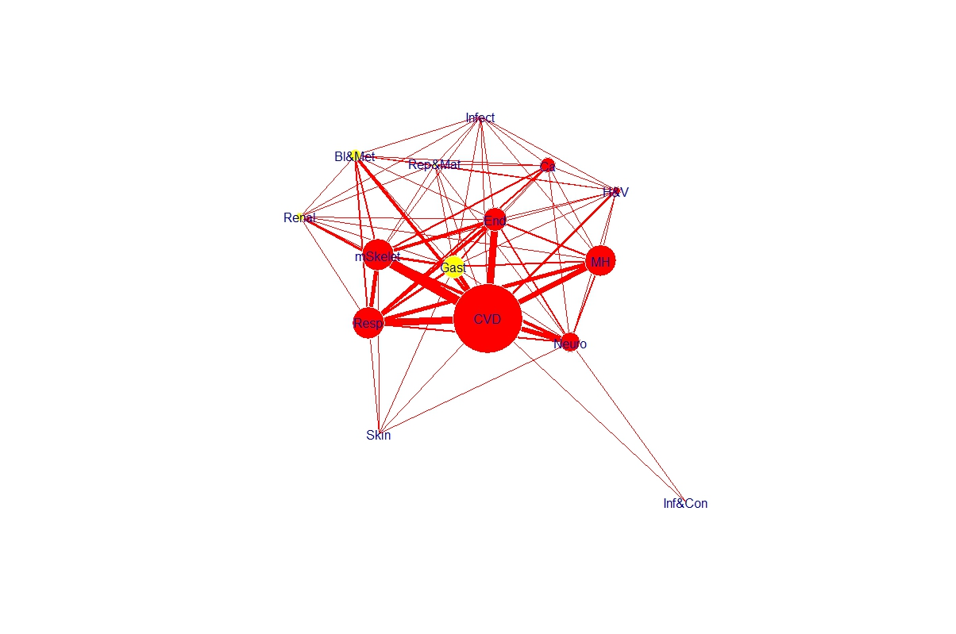

Figure 14: Network graph illustrating the statewide morbidity profile for patients admitted to an acute hospital with a chronic condition in Tasmania over the two years 2015/16 and 2016/17. Node labels refer to AIHW Burden of disease groupings. Edges are weighted according to Odds Ratio. Only significant (p<0.05) edges have been included.

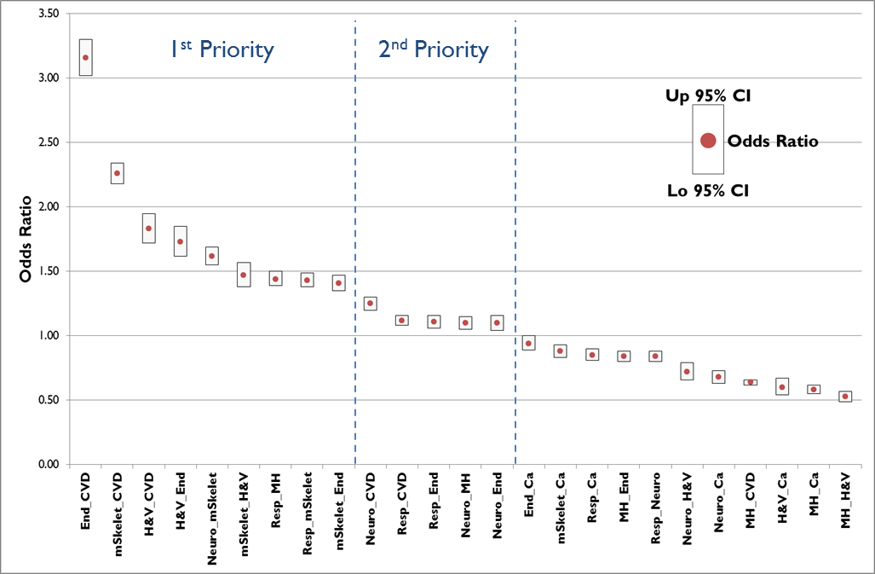

Figure 15: Odds Ratios and 95% Confidence Intervals for significant (p<0.05) edges connecting SoPI priority conditions.

In order to focus and prioritise those conditions with the strongest links, further analysis of the OR was undertaken. Figure 15 shows the OR and 95% Confidence Intervals for all edges that are significant and link SoPI priority conditions. They are grouped in turn into 1st Priority and 2nd Priority groupings. 1st Priority edges are shown in Figure 16.

here are three clusters of conditions. The first cluster is a large one with Musculoskeletal conditions at the centre.
Musculoskeletal conditions could be better integrated with the following five conditions. Cardiovascular disease, Endocrine conditions, Hearing and Vision, Neurological conditions and respiratory conditions.  
The second cluster consuists of Respiratory conditions which are closely related to Mental Health and Substance abuse. 
The last cluster consists of Endocrine conditions, Hearing and vision and cardiovascular conditions are also closely related.

Figure 16: Statewide network graph illustrating the morbidity profile for patients admitted to an acute hospital with a chronic condition in Tasmania over the two years 2015/16 and 2016/17. Edges shown are those that connect SoPI priority conditions, are significant and have an Odds Ratio >1.25.

1. Service Planning
   1. **Which shared conditions should we focus on in Tasmania?**

In addressing this question, two principles were applied:

* Those conditions providing the greatest burden of disease would be prioritised i.e. those conditions highlighted in SoPI 17_18.
* Those shared conditions that have the strongest statistical associations i.e. significant (p<0.05) odds ratio > 1.25.

The analysis would suggest that in order to facilitate provision of services in the acute sector for those with multimorbidity, strengthening collaboration between the following combinations of services should be prioritised:

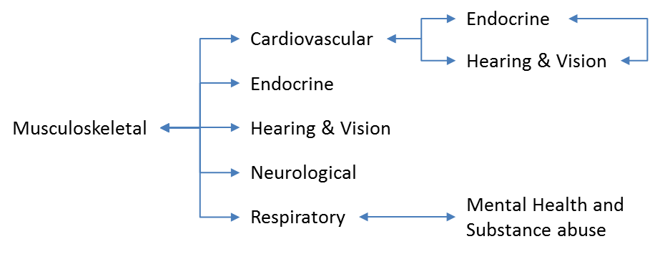

* 1. **What are the options for responding to multimorbidity?**

Options for responding to multimorbidity at a various levels are provided by Rijken et. al (2017) in a policy brief cofounded by the Health Program of the European Union. These are summarised below.

| Macro Level | * Education and Training * Policy and Funding |
| --- | --- |
| Meso Level | * Care coordination * Multiprofessional collaboration * Inter-organisational collaboration * Multi skill recruitment |
| Micro Level | * Periodic and comprehensive needs assessment * Individual care planning * Decision support and shared decision making |

* 1. **Future development**

Further work is required in order to provide a more mature and robust approach to multimorbidity. These include but are not restricted to:

* A definitive list of chronic conditions and associated ICD 10 codes.
* A better understanding of the morbidity profile in the primary care sector. Is this vastly different to the acute sector presented here? If so, it may have service planning implications along the continuum of care.
* What does multimorbidity mean for service providers?
* What does multimorbidity mean for service users?
* Development of a framework to improve care for people with multimorbidity.

1. Appendices

Appendix1: Chronic Conditions List

Appendix 2: Odds Ratios and p values for all conditions

**Appendix 1 - Chronic Conditions List**

| Conditions List | Kohler (2014) | (Knox et al. 2008) | (Salisbury et al. 2011) | (Goodman et al. 2013) | (van den Bussche et al. 2011) | (Orueta et al. 2014) | (Rocca et al. 2014) | (Bahler et al. 2015) | (Fabbri et al. 2015) | (Knesebeck et al. 2015) | (Tonelli et al. 2015) | (Ramond-Roquin et al. 2016) | (Rillamas-Sun et al. 2016) | (Wang et al. 2017) |
| --- | --- | --- | --- | --- | --- | --- | --- | --- | --- | --- | --- | --- | --- | --- |
| Acid related disorders |  |  |  |  |  |  |  | 1 |  |  |  |  |  |  |
| Allergies | 1 |  |  |  |  |  |  |  |  | 1 |  |  |  |  |
| Anaemia | 1 |  |  |  |  |  |  | 1 | 1 | 1 |  |  |  |  |
| Anxiety | 1 | 1 |  |  |  | 1 |  |  |  | 1 |  |  |  |  |
| Arthritis | 1 | 1 |  | 1 | 1 |  | 1 |  |  | 1 | 1 |  |  |  |
| Asthma / COPD | 1 | 1 | 1 | 1 | 1 | 1 | 1 | 1 | 1 | 1 | 1 | 1 | 1 | 1 |
| Atherosclerosis | 1 |  |  |  | 1 |  |  |  |  | 1 |  |  |  |  |
| Atrial Fibrillation |  |  | 1 |  |  | 1 |  |  |  |  | 1 |  |  |  |
| Autism spectrum disorder |  |  |  | 1 |  |  |  |  |  |  |  |  |  |  |
| Cancer | 1 | 1 | 1 | 1 | 1 | 1 | 1 | 1 | 1 | 1 | 1 | 1 | 1 | 1 |
| Cardiac arrhythmias | 1 |  |  | 1 | 1 |  | 1 |  |  | 1 |  |  |  |  |
| Cardiac insufficiency | 1 |  |  |  |  |  |  |  |  | 1 |  |  |  |  |
| Cardiac Valve disorders | 1 |  |  |  |  |  |  |  |  | 1 |  |  |  |  |
| Cardiovascular diseases |  | 1 |  |  |  |  |  | 1 |  |  |  |  |  | 1 |
| Chronic cholecystitis / Gall stones | 1 |  |  |  |  |  |  |  |  | 1 |  |  |  |  |
| Chronic Gastritis / GERD | 1 |  |  |  |  |  |  |  |  | 1 |  |  |  |  |
| Chronic Kidney Disease | 1 |  | 1 | 1 |  |  | 1 |  | 1 | 1 | 1 |  |  | 1 |
| Chronic Pain | 1 | 1 |  |  | 1 |  |  | 1 |  | 1 | 1 | 1 |  |  |
| Cirrhosis |  |  |  |  |  |  |  |  |  |  | 1 |  |  |  |
| Colon problem |  |  |  |  |  |  |  |  |  |  |  | 1 |  |  |
| Congestive heart failure |  | 1 |  |  |  | 1 | 1 |  | 1 |  | 1 | 1 |  |  |
| Coronary artery disease | 1 |  | 1 | 1 |  |  | 1 |  |  | 1 |  | 1 | 1 |  |
| Dementia / Alzheimers / Parkinsons | 1 |  | 1 | 1 |  |  | 1 | 1 | 1 | 1 | 1 |  | 1 |  |
| Depression | 1 | 1 | 1 |  | 1 | 1 | 1 |  | 1 | 1 | 1 | 1 | 1 |  |
| Diabetes (Types I and II) | 1 | 1 | 1 | 1 | 1 | 1 | 1 | 1 |  | 1 | 1 | 1 | 1 | 1 |
| Diverticulosis | 1 |  |  |  |  |  |  |  |  | 1 |  |  |  |  |
| Dizziness | 1 |  |  |  |  |  |  |  |  | 1 |  |  |  |  |
| Epilepsy |  |  | 1 |  |  |  |  | 1 |  |  | 1 |  |  |  |
| Frequent falls |  |  |  |  |  |  |  |  |  |  |  |  | 1 |  |
| Gynaecological problems | 1 |  |  |  |  |  |  |  |  | 1 |  |  |  |  |
| Haemorrhoids | 1 |  |  |  |  |  |  |  |  | 1 |  |  |  |  |
| Hearing loss | 1 |  |  |  |  |  |  |  |  | 1 |  | 1 | 1 |  |
| Heart failure |  |  | 1 | 1 |  |  |  |  |  |  |  |  |  |  |
| Hepatitis |  |  |  | 1 |  |  | 1 |  |  |  | 1 |  |  |  |
| High Cholesterol |  |  |  |  |  |  |  |  |  |  |  | 1 |  |  |
| Hip Fracture |  |  |  |  |  |  |  |  | 1 |  |  |  | 1 |  |
| HIV |  |  |  | 1 |  |  |  | 1 |  |  |  |  |  |  |
| Hyperlipidemia | 1 | 1 |  | 1 | 1 |  | 1 | 1 |  | 1 |  |  |  |  |
| Hypertension | 1 | 1 | 1 | 1 | 1 | 1 | 1 |  | 1 | 1 | 1 | 1 |  |  |
| Hyperuricemia / Gout | 1 |  |  |  | 1 |  |  | 1 |  | 1 |  |  |  |  |
| Hypotension | 1 |  |  |  |  |  |  |  |  |  |  |  |  |  |
| Hypothyroidism |  |  |  |  |  |  |  |  |  |  | 1 |  |  |  |
| Inflammatory bowel disease |  |  |  |  |  |  |  |  |  |  | 1 |  |  |  |
| Insomnia | 1 | 1 |  |  |  |  |  |  |  | 1 |  |  |  |  |
| Intestinal inflammatory diseases |  |  |  |  |  |  |  | 1 |  |  |  |  |  |  |
| Irritable bowel syndrome |  |  |  |  |  |  |  |  |  |  | 1 |  |  |  |
| Ischemic Heart Disease |  | 1 |  |  | 1 | 1 |  |  | 1 |  |  |  |  |  |
| Learning disability |  |  | 1 |  |  |  |  |  |  |  |  |  |  |  |
| Liver disease | 1 |  |  |  |  |  |  |  |  | 1 |  |  |  |  |
| Mental health problems |  | 1 | 1 | 1 |  |  | 1 | 1 |  |  |  |  |  | 1 |
| Migraine / Chronic headache | 1 |  |  |  |  |  |  | 1 |  | 1 |  |  |  |  |
| Multiple sclerosis |  |  |  |  |  |  |  |  |  |  | 1 |  |  |  |
| Myocardial infarct |  |  |  |  |  |  |  |  |  |  | 1 |  |  |  |
| Neuropathies | 1 |  |  |  |  |  |  |  |  | 1 |  |  |  |  |
| Osteoarthritis |  | 1 |  |  |  |  |  |  |  |  |  | 1 | 1 | 1 |
| Osteoporosis | 1 |  |  | 1 | 1 |  | 1 | 1 |  | 1 |  | 1 |  | 1 |
| Other Joint Diseases |  |  |  |  |  |  |  |  | 1 |  |  | 1 |  |  |
| Overweight / Obesity | 1 |  | 1 |  |  |  |  |  |  | 1 |  | 1 |  |  |
| Peptic ulcer disease |  |  |  |  |  |  |  |  |  |  | 1 |  |  |  |
| Peripheral vascular disease |  | 1 |  |  |  |  |  |  |  |  | 1 |  |  |  |
| Prostatic hyperplasia | 1 |  |  |  |  |  |  |  |  | 1 |  |  |  |  |
| Psoriasis | 1 |  |  |  |  |  |  |  |  | 1 |  |  |  |  |
| Rheumatoid Arthritis | 1 | 1 |  |  |  |  |  |  |  | 1 |  | 1 |  |  |
| Rheumatological disorders |  |  |  |  |  |  |  | 1 |  |  |  |  |  |  |
| Severe constipation |  |  |  |  |  |  |  |  |  |  | 1 |  |  |  |
| Sexual dysfunction | 1 |  |  |  |  |  |  |  |  |  |  |  |  |  |
| Smoking | 1 |  |  |  |  |  |  |  |  |  |  |  |  |  |
| Somatoform disorders | 1 |  |  |  |  |  |  |  |  | 1 |  |  |  |  |
| Stomach problem (incl GOR) |  | 1 |  |  |  |  |  |  |  |  |  | 1 |  |  |
| Stroke / Cerebrovascular | 1 | 1 | 1 | 1 |  | 1 | 1 |  | 1 | 1 | 1 | 1 | 1 |  |
| Substance abuse |  |  |  | 1 |  |  | 1 |  |  |  | 1 |  |  |  |
| Thyroid disease | 1 |  | 1 |  | 1 |  |  | 1 |  | 1 |  | 1 |  |  |
| Tuberculosis |  |  |  |  |  |  |  | 1 |  |  |  |  |  |  |
| Urinary Incontinence | 1 |  |  |  |  |  |  |  |  | 1 |  |  | 1 |  |
| Urinary Tract calculi | 1 |  |  |  |  |  |  |  |  | 1 |  |  |  |  |
| Varicosis | 1 |  |  |  | 1 |  |  |  | 1 | 1 |  |  |  |  |
| Vision loss | 1 |  |  |  | 1 |  |  | 1 |  | 1 |  | 1 | 1 |  |

**Appendix 2 – Odds Ratios and p values for all conditions**

| **Edge_Label** | **Statewide** | | **Southern region** | | **Northern region** | |
| --- | --- | --- | --- | --- | --- | --- |
| **OR** | **p** | **OR** | **p** | **OR** | **p** |
| Neuro_Inf&Con | 13.54 | 0.0000 | 11.87 | 0.0000 | 16.95 | 0.0000 |
| MH_Infect | 3.64 | 0.0000 | 3.38 | 0.0000 | 3.85 | 0.0000 |
| End_CVD | 3.16 | 0.0000 | 3.19 | 0.0000 | 3.13 | 0.0000 |
| Renal_CVD | 3.10 | 0.0000 | 3.37 | 0.0000 | 2.86 | 0.0000 |
| Renal_Bl&Met | 3.09 | 0.0000 | 3.23 | 0.0000 | 2.98 | 0.0000 |
| Renal_End | 2.94 | 0.0000 | 2.87 | 0.0000 | 2.98 | 0.0000 |
| Skin_mSkelet | 2.44 | 0.0000 | 2.87 | 0.0001 | 2.18 | 0.0001 |
| mSkelet_CVD | 2.26 | 0.0000 | 2.22 | 0.0000 | 2.27 | 0.0000 |
| Ca_Bl&Met | 2.06 | 0.0000 | 1.96 | 0.0000 | 2.15 | 0.0000 |
| Gast_Bl&Met | 2.05 | 0.0000 | 2.13 | 0.0000 | 2.00 | 0.0000 |
| CVD_Bl&Met | 1.90 | 0.0000 | 1.90 | 0.0000 | 1.90 | 0.0000 |
| Rep&Mat_Neuro | 1.87 | 0.0000 | 1.54 | 0.0000 | 2.17 | 0.0000 |
| H&V_CVD | 1.83 | 0.0000 | 1.53 | 0.0000 | 1.98 | 0.0000 |
| Rep&Mat_Renal | 1.74 | 0.0000 | 2.04 | 0.0000 | 1.54 | 0.0000 |
| H&V_End | 1.73 | 0.0000 | 1.49 | 0.0000 | 1.84 | 0.0000 |
| mSkelet_Bl&Met | 1.66 | 0.0000 | 1.57 | 0.0000 | 1.74 | 0.0000 |
| Neuro_mSkelet | 1.62 | 0.0000 | 1.74 | 0.0000 | 1.55 | 0.0000 |
| End_Bl&Met | 1.62 | 0.0000 | 1.74 | 0.0000 | 1.52 | 0.0000 |
| mSkelet_Renal | 1.61 | 0.0000 | 1.58 | 0.0000 | 1.61 | 0.0000 |
| mSkelet_H&V | 1.47 | 0.0000 | 1.19 | 0.0022 | 1.59 | 0.0022 |
| Resp_MH | 1.44 | 0.0000 | 1.35 | 0.0000 | 1.56 | 0.0000 |
| Resp_mSkelet | 1.43 | 0.0000 | 1.48 | 0.0000 | 1.37 | 0.0000 |
| mSkelet_End | 1.41 | 0.0000 | 1.34 | 0.0000 | 1.46 | 0.0000 |
| Neuro_CVD | 1.25 | 0.0000 | 1.21 | 0.0000 | 1.32 | 0.0000 |
| Resp_Renal | 1.25 | 0.0000 | 1.32 | 0.0000 | 1.19 | 0.0000 |
| Resp_Bl&Met | 1.23 | 0.0000 | 1.30 | 0.0000 | 1.17 | 0.0000 |
| Resp_CVD | 1.12 | 0.0000 | 1.27 | 0.0000 | 1.00 | 0.0000 |
| Resp_End | 1.11 | 0.0000 | 1.13 | 0.0003 | 1.08 | 0.0003 |
| mSkelet_Gast | 0.89 | 0.0000 | 0.76 | 0.0000 | 0.95 | 0.0000 |
| mSkelet_Ca | 0.88 | 0.0000 | 0.84 | 0.0000 | 0.92 | 0.0000 |
| Resp_Ca | 0.85 | 0.0000 | 0.86 | 0.0003 | 0.86 | 0.0003 |
| Gast_End | 0.85 | 0.0000 | 0.87 | 0.0011 | 0.82 | 0.0011 |
| MH_End | 0.84 | 0.0000 | 0.79 | 0.0000 | 0.90 | 0.0000 |
| Resp_Neuro | 0.84 | 0.0000 | 0.86 | 0.0000 | 0.84 | 0.0000 |
| MH_Gast | 0.83 | 0.0000 | 0.76 | 0.0000 | 0.91 | 0.0000 |
| MH_Renal | 0.80 | 0.0000 | 0.74 | 0.0000 | 0.86 | 0.0000 |
| Rep&Mat_Ca | 0.76 | 0.0000 | 0.69 | 0.0003 | 0.83 | 0.0003 |
| Gast_CVD | 0.75 | 0.0000 | 0.71 | 0.0000 | 0.76 | 0.0000 |
| Neuro_H&V | 0.72 | 0.0000 | 0.81 | 0.0033 | 0.68 | 0.0033 |
| Renal_Gast | 0.70 | 0.0000 | 0.73 | 0.0000 | 0.66 | 0.0000 |
| Neuro_Ca | 0.68 | 0.0000 | 0.61 | 0.0000 | 0.74 | 0.0000 |
| MH_CVD | 0.64 | 0.0000 | 0.61 | 0.0000 | 0.68 | 0.0000 |
| H&V_Ca | 0.60 | 0.0000 | 0.58 | 0.0000 | 0.63 | 0.0000 |
| MH_Ca | 0.58 | 0.0000 | 0.51 | 0.0000 | 0.65 | 0.0000 |
| Infect_End | 0.58 | 0.0000 | 0.52 | 0.0000 | 0.65 | 0.0000 |
| Gast_Ca | 0.57 | 0.0000 | 0.56 | 0.0000 | 0.57 | 0.0000 |
| Rep&Mat_H&V | 0.55 | 0.0000 | 0.70 | 0.0234 | 0.46 | 0.0234 |
| H&V_Gast | 0.54 | 0.0000 | 0.52 | 0.0000 | 0.52 | 0.0000 |
| MH_H&V | 0.53 | 0.0000 | 0.51 | 0.0000 | 0.56 | 0.0000 |
| Rep&Mat_Gast | 0.47 | 0.0000 | 0.62 | 0.0000 | 0.39 | 0.0000 |
| mSkelet_Infect | 0.44 | 0.0000 | 0.40 | 0.0000 | 0.50 | 0.0000 |
| Neuro_Gast | 0.43 | 0.0000 | 0.41 | 0.0000 | 0.45 | 0.0000 |
| Infect_CVD | 0.34 | 0.0000 | 0.33 | 0.0000 | 0.36 | 0.0000 |
| Infect_H&V | 0.24 | 0.0000 | 0.24 | 0.0000 | 0.27 | 0.0000 |
| Skin_Resp | 1.91 | 0.0001 | 1.44 | 0.2915 | 2.13 | 0.2915 |
| Neuro_MH | 1.10 | 0.0001 | 0.91 | 0.0083 | 1.30 | 0.0083 |
| Rep&Mat_mSkelet | 1.16 | 0.0002 | 1.34 | 0.0000 | 1.04 | 0.0000 |
| Neuro_End | 1.10 | 0.0002 | 1.01 | 0.7404 | 1.19 | 0.7404 |
| Rep&Mat_Bl&Met | 1.23 | 0.0004 | 1.42 | 0.0001 | 1.13 | 0.0001 |
| Resp_Gast | 0.92 | 0.0004 | 0.96 | 0.2786 | 0.87 | 0.2786 |
| Renal_Infect | 0.56 | 0.0004 | 0.60 | 0.0266 | 0.54 | 0.0266 |
| Infect_Gast | 1.29 | 0.0008 | 1.28 | 0.0250 | 1.39 | 0.0250 |
| Rep&Mat_Infect | 0.53 | 0.0015 | 0.61 | 0.0853 | 0.49 | 0.0853 |
| Infect_Ca | 0.73 | 0.0030 | 0.69 | 0.0115 | 0.75 | 0.0115 |
| H&V_Bl&Met | 0.86 | 0.0064 | 0.93 | 0.4576 | 0.82 | 0.4576 |
| Skin_CVD | 1.60 | 0.0084 | 1.15 | 0.7166 | 1.89 | 0.7166 |
| Infect_Bl&Met | 1.30 | 0.0094 | 1.41 | 0.0082 | 1.15 | 0.0082 |
| Inf&Con_CVD | 0.23 | 0.0095 | 0.25 | 0.0408 | 0.24 | 0.0408 |
| End_Ca | 0.94 | 0.0320 | 0.83 | 0.0001 | 1.03 | 0.0001 |
| Skin_Gast | 1.53 | 0.0328 | 1.28 | 0.6100 | 1.59 | 0.6100 |
| Skin_Neuro | 1.54 | 0.0345 | 0.99 | 1.0000 | 1.97 | 1.0000 |
| Rep&Mat_CVD | 0.93 | 0.0379 | 1.06 | 0.3100 | 0.82 | 0.3100 |
| Neuro_Renal | 0.00 | 0.0577 | 0.94 | 0.3721 | 1.21 | 0.3721 |
| CVD_Ca | 0.00 | 0.0647 | 0.94 | 0.0720 | 1.17 | 0.0720 |
| Inf&Con_End | 0.00 | 0.0778 | 0.00 | 0.1506 | 0.00 | 0.1506 |
| Resp_Rep&Mat | 0.00 | 0.0812 | 1.11 | 0.1542 | 0.81 | 0.1542 |
| mSkelet_Inf&Con | 0.00 | 0.0848 | 0.24 | 0.2316 | 0.00 | 0.2316 |
| Neuro_Bl&Met | 0.00 | 0.0876 | 0.99 | 0.7938 | 1.14 | 0.7938 |
| Skin_Bl&Met | 0.00 | 0.1022 | 1.51 | 0.4324 | 1.55 | 0.4324 |
| Renal_Ca | 0.00 | 0.1032 | 0.93 | 0.3125 | 1.21 | 0.3125 |
| Neuro_Infect | 0.00 | 0.1147 | 0.80 | 0.0673 | 0.92 | 0.0673 |
| MH_Bl&Met | 0.00 | 0.1542 | 0.92 | 0.0797 | 1.16 | 0.0797 |
| Rep&Mat_MH | 0.00 | 0.1719 | 1.12 | 0.1027 | 1.05 | 0.1027 |
| Skin_Ca | 0.00 | 0.1998 | 0.26 | 0.0719 | 0.94 | 0.0719 |
| Inf&Con_Ca | 0.00 | 0.2112 | 0.00 | 0.2848 | 0.00 | 0.2848 |
| Resp_Inf&Con | 0.00 | 0.2387 | 0.54 | 0.6126 | 0.00 | 0.6126 |
| Inf&Con_Gast | 0.00 | 0.2932 | 0.41 | 0.6082 | 0.00 | 0.6082 |
| Skin_Rep&Mat | 0.00 | 0.3047 | 1.52 | 0.7237 | 1.41 | 0.7237 |
| Rep&Mat_End | 0.00 | 0.3159 | 1.02 | 0.7873 | 0.90 | 0.7873 |
| Inf&Con_H&V | 0.00 | 0.4774 | 0.00 | 0.7510 | 0.00 | 0.7510 |
| Renal_Inf&Con | 0.00 | 0.5214 | 0.00 | 0.7168 | 0.00 | 0.7168 |
| Skin_H&V | 0.00 | 0.5291 | 0.69 | 0.8253 | 1.41 | 0.8253 |
| Skin_End | 0.00 | 0.5312 | 0.92 | 0.9687 | 1.27 | 0.9687 |
| Skin_Renal | 0.00 | 0.5475 | 1.34 | 0.7853 | 1.19 | 0.7853 |
| Skin_Infect | 0.00 | 0.5850 | 0.99 | 1.0000 | 0.00 | 1.0000 |
| Rep&Mat_Inf&Con | 0.00 | 0.7104 | 0.00 | 0.9548 | 0.00 | 0.9548 |
| Renal_H&V | 0.00 | 0.7242 | 0.98 | 0.9183 | 0.93 | 0.9183 |
| Resp_H&V | 0.00 | 0.7966 | 0.99 | 0.8611 | 0.98 | 0.8611 |
| Resp_Infect | 0.00 | 0.8468 | 0.92 | 0.4655 | 1.11 | 0.4655 |
| Inf&Con_Bl&Met | 0.00 | 0.8967 | 0.75 | 1.0000 | 0.00 | 1.0000 |
| MH_Inf&Con | 0.00 | 0.9930 | 0.74 | 0.8679 | 1.08 | 0.8679 |
| mSkelet_MH | 0.00 | 1.0000 | 0.98 | 0.5196 | 1.03 | 0.5196 |
| Skin_Inf&Con | 0.00 | 1.0000 | 0.00 | 1.0000 | 0.00 | 1.0000 |
| Infect_Inf&Con | 0.00 | 1.0000 | 0.00 | 1.0000 | 0.00 | 1.0000 |

1. Bibliography

van den Akker, M, Buntinx, F & Knottnerus, JA 1996, ‘Comorbidity or multimorbidity: what’s in a name? A review of literature’, *European Journal of General Practice*, vol. 2, no. 2, pp. 65–70.

Bahler, C, Huber, C, Brungger, B & Reich, O 2015, ‘Multimorbidity, health care utilization and costs in an elderly community-dwelling population: a claims data based observational study’, *BMC HEALTH SERVICES RESEARCH*, vol. 15, viewed 16 April 2017, <https://login.ezproxy.utas.edu.au/login?url=http://search.ebscohost.com/login.aspx?direct=true&db=edswsc&AN=000348430800001&site=eds-live>.

Britt, HC, Harrison, CM, Miller, GC, Knox, SA & others 2008, ‘Prevalence and patterns of multimorbidity in Australia’, *Med J Aust*, vol. 189, no. 2, pp. 72–77.

van den Bussche, H, Koller, D, Kolonko, T, Hansen, H, Wegscheider, K, Glaeske, G, von Leitner, E-C, Schäfer, I & Schön, G 2011, ‘Which chronic diseases and disease combinations are specific to multimorbidity in the elderly? Results of a claims data based cross-sectional study in Germany’, *BMC Public Health*, vol. 11, pp. 101–101.

DHHS 2016, *Healthy Tasmania Five Year Strategic Plan*, July, Department of Health and Human Services, Tasmania, Australia, p. 34.

Eckardt, M, Brettschneider, C, van den Bussche, H, König, H-H & MultiCare Study Group 2017, ‘Analysis of Health Care Costs in Elderly Patients with Multiple Chronic Conditions Using a Finite Mixture of Generalized Linear Models: Finite Mixture Model of Multimorbidity Costs’, *Health Economics*, vol. 26, no. 5, pp. 582–599.

Fabbri, E, An, Y, Zoli, M, Simonsick, EM, Guralnik, JM, Bandinelli, S, Boyd, CM & Ferrucci, L 2015, ‘Aging and the Burden of Multimorbidity: Associations With Inflammatory and Anabolic Hormonal Biomarkers’, *The Journals of Gerontology: Series A*, vol. 70, no. 1, pp. 63–70.

Goodman, RA, Posner, SF, Huang, ES, Parekh, AK & Koh, HK 2013, ‘Defining and Measuring Chronic Conditions: Imperatives for Research, Policy, Program, and Practice’, *Preventing Chronic Disease*, vol. 10.

Harrison, C, Henderson, J, Miller, G & Britt, H 2016, ‘The prevalence of complex multimorbidity in Australia’, *Australian and New Zealand Journal of Public Health*, vol. 40, no. 3, pp. 239–244.

Knesebeck, O von dem, Bickel, H, Fuchs, A, Gensichen, J, Höfels, S, Riedel-Heller, SG, König, H-H, Mergenthal, K, Schön, G, Wegscheider, K, Weyerer, S, Wiese, B, Scherer, M, Bussche, H van den & Schäfer, I 2015, ‘Social inequalities in patient-reported outcomes among older multimorbid patients – results of the MultiCare cohort study’, *International Journal for Equity in Health*, vol. 14, no. 1, p. 17.

Knox, SA, Harrison, CM, Britt, HC & Henderson, JV 2008, ‘Estimating prevalence of common chronic morbidities in Australia’, *The Medical Journal of Australia*, vol. 189, no. 2, pp. 66–70.

Le Corvoisier, P, Bastuji-Garin, S, Renaud, B, Mahe, I, Bergmann, J-F, Perchet, H, Paillaud, E, Mottier, D & Montagne, O 2015, ‘Functional status and co-morbidities are associated with in-hospital mortality among older patients with acute decompensated heart failure: a multicentre prospective cohort study’, *Age and Ageing*, vol. 44, no. 2, pp. 225–231.

Navickas, R, Petric, V-K, Ministry of Health, Republic of Slovenia, Ljubljana, Slovenia, Feigl, AB, Harvard T.H. Chan School of Public Health, Boston, MA, USA; Abt Associates, Cambridge, MA, USA, Seychell, M & Directorate General for Health and Food Safety, European Commission, Brussels, Belgium 2016, ‘Multimorbidity: What do we know? What should we do?’, *Journal of Comorbidity*, vol. 6, no. 1, pp. 4–11.

Orueta, JF, García-Álvarez, A, García-Goñi, M, Paolucci, F & Nuño-Solinís, R 2014, ‘Prevalence and Costs of Multimorbidity by Deprivation Levels in the Basque Country: A Population Based Study Using Health Administrative Databases’, in CM Schooling (ed.), *PLoS ONE*, vol. 9, no. 2, p. e89787.

Picco, L, Achilla, E, Abdin, E, Chong, SA, Vaingankar, JA, McCrone, P, Chua, HC, Heng, D, Magadi, H, Ng, LL, Prince, M & Subramaniam, M 2016, ‘Economic burden of multimorbidity among older adults: impact on healthcare and societal costs’, *BMC Health Services Research*, vol. 16, no. 1, viewed 26 September 2016, <http://bmchealthservres.biomedcentral.com/articles/10.1186/s12913-016-1421-7>.

Prior, A, Fenger-Grøn, M, Larsen, KK, Larsen, FB, Robinson, KM, Nielsen, MG, Christensen, KS, Mercer, SW & Vestergaard, M 2016, ‘The Association Between Perceived Stress and Mortality Among People With Multimorbidity: A Prospective Population-Based Cohort Study’, *American Journal of Epidemiology*, vol. 184, no. 3, pp. 199–210.

Ramond-Roquin, A, Haggerty, J, Lambert, M, Almirall, J & Fortin, M 2016, ‘Different Multimorbidity Measures Result in Varying Estimated Levels of Physical Quality of Life in Individuals with Multimorbidity: A Cross-Sectional Study in the General Population’, *BioMed Research International*, viewed 7 July 2017, <https://www.hindawi.com/journals/bmri/2016/7845438/>.

Rijken, M, Struckmann, V, van der Heide, I, Hujala, A, Barbabella, F, van Ginneken, E & Schellevis, F 2017, *How to improve care for people with multimorbidity in Europe?*, Health Systems and Policy Analysis, Policy Brief 23, ICARE4U, The Kings Fund, viewed 10 May 2017, <http://www.euro.who.int/__data/assets/pdf_file/0004/337585/PB_23.pdf?ua=1&utm_source=The%20King%27s%20Fund%20newsletters&utm_medium=email&utm_campaign=8227959_NEWSL_ICB%202017-05-10&dm_i=21A8,4WCQF,PJI4RT,IPJBB,1>.

Rillamas-Sun, E, LaCroix, AZ, Bell, CL, Ryckman, K, Ockene, JK & Wallace, RB 2016, ‘The Impact of Multimorbidity and Coronary Disease Comorbidity on Physical Function in Women Aged 80 Years and Older: The Women’s Health Initiative’, *The Journals of Gerontology: Series A*, vol. 71, no. Suppl_1, pp. S54–S61.

Rocca, WA, Boyd, CM, Grossardt, BR, Bobo, WV, Rutten, LJ, Roger, VL, Ebbert, JO, Therneau, TM, Yawn, BP & Sauver, JLS 2014, ‘The prevalence of multimorbidity in a geographically defined American population: patterns by age, sex, and ethnicity’, *Mayo Clinic proceedings*, vol. 89, no. 10, pp. 1336–1349.

Salisbury, C, Johnson, L, Purdy, S, Valderas, JM & Montgomery, AA 2011, ‘Epidemiology and impact of multimorbidity in primary care: a retrospective cohort study’, *Br J Gen Pract*, vol. 61, no. 582, pp. e12–e21.

Specogna, AV, Turin, TC, Patten, SB & Hill, MD 2017, ‘Hospital treatment costs and length of stay associated with hypertension and multimorbidity after hemorrhagic stroke’, *BMC Neurology*, vol. 17, p. 158.

Tetzlaff, J, Muschik, D, Epping, J, Eberhard, S & Geyer, S 2017, ‘Expansion or compression of multimorbidity? 10-year development of life years spent in multimorbidity based on health insurance claims data of Lower Saxony, Germany’, *International Journal of Public Health*.

Tonelli, M, Wiebe, N, Fortin, M, Guthrie, B, Hemmelgarn, BR, James, MT, Klarenbach, SW, Lewanczuk, R, Manns, BJ, Ronksley, P, Sargious, P, Straus, S & Quan, H 2015, ‘Methods for identifying 30 chronic conditions: application to administrative data’, *BMC Medical Informatics and Decision Making*, vol. 15, viewed 20 May 2017, <http://www.ncbi.nlm.nih.gov/pmc/articles/PMC4415341/>.

Valderas, JM, Starfield, B, Sibbald, B, Salisbury, C & Roland, M 2009, ‘Defining Comorbidity: Implications for Understanding Health and Health Services’, *The Annals of Family Medicine*, vol. 7, no. 4, pp. 357–363.

Wang, L, Palmer, AJ, Otahal, P, Cocker, F & Sanderson, K 2017, ‘Multimorbidity and Health Care Service Utilization in the Australian Workforce: Findings from the National Health Survey’, *Journal of Occupational and Environmental Medicine*, vol. Publish Ahead of Print, viewed 12 July 2017, <https://insights-ovid-com.ezproxy.utas.edu.au/crossref?an=00043764-900000000-98889>.

Weir, DL, Majumdar, SR, McAlister, FA, Marrie, TJ & Eurich, DT 2015, ‘The impact of multimorbidity on short-term events in patients with community-acquired pneumonia: prospective cohort study’, *Clinical Microbiology and Infection*, vol. 21, no. 3, p. 264.e7-264.e13.