Vancomycin resistant enterococci surveillance.
Report, 2014 to 2019
Vancomycin resistant enterococci surveillance. Report, 2014 to 2019
Department of Health, Tasmania
Published 2021
Copyright—Department of Health, Tasmania
Permission to copy is granted provided the source is acknowledged
Authors
- Ms Fiona Wilson, Clinical Nurse Consultant, TIPCU
- Dr Tara Anderson, Specialist Medical Advisor, TIPCU
- Ms Lucy Hughson, Clinical Nurse Consultant, TIPCU
- Ms Anne Wells, Nursing Director, CDPU
Suggested reference: Wilson, F., Anderson, T., Wells, A. (2021). Vancomycin resistant enterococci surveillance. Report, 2014 to 2019. Hobart: Department of Health.
Reviewed and approved by the:
- Tasmanian Health Service - Executive Director of Nursing North, Executive Director of Nursing North West, Nursing Director South – Critical Care, Clinical Support and Investigations
- Tasmanian Department of Health – Deputy Director of Public Health

Contents

Background 4
Definitions 5
Surveillance process 6
Newly identified vancomycin resistant enterococci in Tasmania 7
VRE screening effort 10
Burden of VRE infection 11
Public hospital identified VRE 13
Royal Hobart Hospital (RHH) 13
Launceston General Hospital (LGH) 15
North West Regional Hospital (NWRH) 17
Mersey Community Hospital (MCH) 19
Key findings 21
References 22

Figure 1 VRE - Tasmanian number and incidence per financial year 7
Figure 2 VRE - classification per financial year 8
Figure 3 VRE – genotype per financial year 9
Figure 4 VRE at RHH – newly identified by financial year 13
Figure 5 VRE at RHH – newly identified genotype by financial year 13
Figure 6 VRE at LGH – newly identified by financial year 15
Figure 7 VRE at LGH – newly identified genotype by financial year 15
Figure 8 VRE at NWRH – newly identified by financial year 17
Figure 9 VRE at NWRH – newly identified genotype by financial year 17
Figure 10 VRE at MCH – newly identified by financial year 19
Figure 11 VRE at MCH – newly identified genotype by financial year 19

Background
Enterococci are Gram positive bacteria that are normally present in the human gastrointestinal and female genital tract. Enterococci are opportunistic pathogens that may cause infections, particularly in vulnerable people and most commonly in the urinary tract and intra-abdominal sites. These infections may be complicated by bloodstream infections. E. faecium and E. faecalis are the most common enterococci that cause infections.
Enterococci are naturally resistant to a number of commonly used antimicrobials. Enterococci may also acquire resistance to the antibiotic vancomycin by obtaining either vanA or vanB genes which render that enterococcal organism resistant to vancomycin. These enterococci are called vancomycin resistant enterococci (VRE). Different sequence types (ST) of VRE have been identified with specialised genetic typing methods such as multi-locus sequence typing (MLST).
VRE are known to be acquired by patients in healthcare facilities. Factors that can contribute to the transmission within healthcare include inadequate infection control practices, overuse of antibiotics and suboptimal environmental cleanliness. Infections due to VRE can be more difficult to treat then those caused by enterococci sensitive to vancomycin.
Since 2008, VRE colonisation or infection has been a notifiable condition in Tasmania under the Public Health Act 1997 (Tasmanian Government 2017) with all isolates of VRE being required to be notified to Public Health Services. The Tasmanian Infection and Prevention and Control Unit (TIPCU) coordinates VRE surveillance in Tasmania in accordance with the ‘VRE surveillance protocol’ (Wilson, Hughson, Anderson and Wells, 2018).
VRE was first identified in Tasmania in 2007. Since 2015 there has been a significant increase in the identification of people who are colonised or infected with VRE, with differing epidemiology identified across Tasmania. In response, the existing State-wide VRE screening policy was reviewed and in June 2017, the Tasmanian Health Service ‘Multi-Resistant Organism Screening and Clearance Protocol’ was endorsed and provides consistency of screening practices across Tasmania.
VanB E. faecium was the commonest VRE identified in Tasmania until mid-2018 with the dominant ST being ST796. This reflected what was occurring nationally with ST796 being the dominant vanB VRE ST from 2014, largely due to its widespread dissemination throughout Southeast Australia. Reflecting the national shift from vanB to vanA E. faecium in late 2013, however, vanA E. faecium became the commonest VRE identified from late 2018 in Tasmania with a polyclonal increase with different ST identified.
This report provides data for VRE colonisation and infection in Tasmania from July 2014 to June 2019 with a focus on public hospital identified VRE.

Definitions
Inpatient healthcare facility – facility where patients can be admitted for overnight stay and includes acute private or public hospitals, rural hospital, sub-acute facility or long term care facility.
VRE – E. faecalis or E. faecium isolate with vancomycin MIC >4 mg/L or isolate demonstrated to contain vanA and/or vanB gene.
All VRE notified are classified according to the following definitions:
- VRE screening specimen – VRE identified from a rectal swab and/or an anal swab and/or a faecal specimen
- VRE clinical specimen – VRE identified from any other body site that is not considered to be a screening specimen site.
- VRE infection - a positive culture for VRE from either a sterile site or from a non-sterile site where VRE specific antibiotic therapy is administered/prescribed by a clinician.
- VRE colonisation - a positive culture for VRE associated with a non-sterile site isolate where VRE specific antibiotic therapy is NOT administered/prescribed by a clinician.
- Subsequent clinical isolate – the first clinical specimen identified where the person’s first isolate was a screening specimen.
- Unknown – either the specimen species, gene or whether the specimen represented infection or colonisation is no known.
Excluded data
VRE isolates that represent:
- any subsequent positive screening specimen following an initial VRE isolated from a screening or clinical specimen
- any subsequent clinical specimen that follows an initial VRE isolated from a clinical specimen
- any positive clinical specimens following a ‘subsequent clinical isolate’.
The geographical location of VRE screening is reported but not the location of VRE acquisition. Acquisition data is not collected or reported by TIPCU.

Surveillance process
- Individual isolates of VRE are notified by the identifying laboratory to Public Health Services (PHS).
- An individual’s first VRE isolate is entered into the TIPCU spreadsheet within two working days of receipt. Subsequent isolates are only entered if the first isolate identified was a screening specimen and the subsequent isolate was a clinical specimen.
  - For new isolates identified in a hospital, the data collection spreadsheet is sent electronically monthly from TIPCU to the relevant infection control personnel for validation.
  - For new isolates identified in the community, the data collection form is sent via mail to the relevant General Practitioner for completion of required information.
- Upon receipt of the returned data, TIPCU personnel make any required changes to the data.
- Validation of data collected on all new VRE isolates is performed quarterly using the following process:
- Identifying laboratories perform a data extraction of all VRE isolates identified within Tasmania in the relevant quarter and send the extracted data to TIPCU.
- TIPCU cross checks data extraction with VRE isolates against those notified to Public Health within the same quarter.
- Any discrepancies are investigated by TIPCU with the relevant laboratory.
- TIPCU sends the updated data to hospital infection control personnel to cross check against their records of VRE isolates to identify any data errors.
- The validated data is returned to TIPCU
- Electronic forms are stored in the TIPCU shared drive.
- Hard copy laboratory reports are securely stored by TIPCU for at least twelve months and then destroyed.

Newly identified vancomycin resistant enterococci in Tasmania
The following graphs illustrate the total number of individuals identified in Tasmania from July 2014 who have had VRE isolated from either a screening or clinical specimen. These isolates are from public and private hospitals, rural hospitals, GP clinics and long term care facilities.
Figure 1 presents the total number and incidence per 100 000 population of all newly reported VRE in Tasmania per financial year.
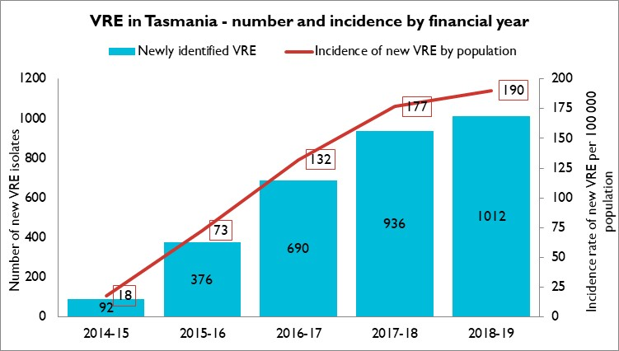
Figure 1 VRE - Tasmanian number and incidence per financial year
E. faecium accounted for the majority of VRE identified in Tasmania with only 21 (0.7%) E. faecalis identified in the 5-year period. Newly notified VRE quadrupled between 2014-15 and 2015-16 and increased each subsequent year, levelling off in the past two financial years.
The increase in newly identified VRE over the past four financial years is likely to be multifactorial. It likely represents a real increase in VRE colonisation and infection. although it is likely that the increased screening thought the implementation of consistent state-wide screening protocols also contributed.
Although direct comparisons cannot be made with other Australian States and Territories, VRE burden has increased nationally over the same time frame.

Error! Reference source not found. presents the total number of all newly reported VRE classified by infection or colonisation and presents the percentage of these newly reported isolates that represent an infection.
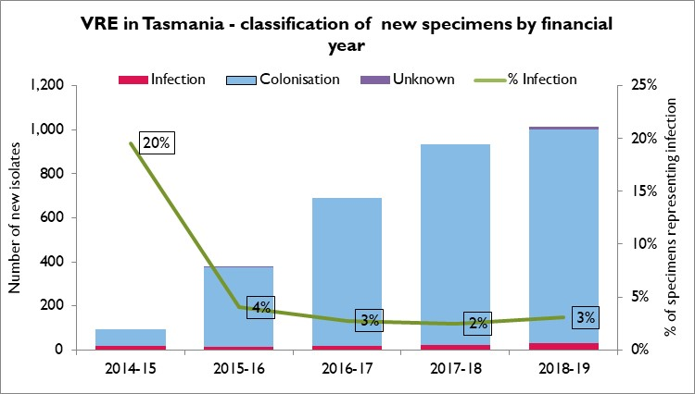
Figure 2 VRE - classification per financial year
The number of people newly identified with VRE colonisation has increased from 2014-15 while the proportion of new isolates that represent infections has remained relatively stable over the past four financial years. Urinary tract infections account for most of the newly identified VRE infections.

presents the total number of all newly reported VRE classified by VRE genotype.
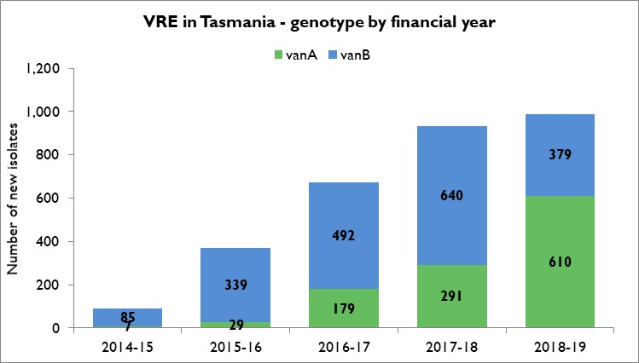
Figure 3 VRE – genotype per financial year
Over the past five financial years, the proportion of newly reported vanA E. faecium increased from 8% of new isolates in 2014-16 to 60% in 2018-19. This shift in the dominant genotype from vanB E. faecium to vanA E. faecium is similar to what has been reported from other Australian States and Territories.
Until mid-2018, vanB E. faecium was the commonest VRE organism identified in Tasmania with the dominant ST being ST796. This reflected what was occurring nationally with ST796 being the dominant vanB E. faecium ST from 2014, largely due to its widespread dissemination throughout Southeast Australia.
There was a national shift from vanB to vanA E. faecium in late 2013. In Tasmania, however, vanA E. faecium became the most common VRE identified from late 2018 with a polyclonal increase with different ST identified.

VRE screening effort
The volume of VRE screening has increased in Tasmania over the past five years. This is likely to reflect both improved adherence to the revised Tasmanian Health Service (THS) VRE screening protocol as well as increased VRE contact screening due to the increased VRE burden in healthcare facilities.
Table 1 presents the VRE screening effort across the four larger acute public hospitals, demonstrating the numbers of screening specimens tested and the number and percentage of these specimens that have cultured VRE.
Table 1 Screening specimens tested and results
Year | RHH  Screening specimens tested | RHH  Positive specimens | LGH  Screening specimens tested | LGH  Positive specimens | MCH  Screening specimens tested | MCH  Positive specimens | NWRH  Screening specimens tested | NWRH  Positive specimens
2014 | 1962 | 12 (0.6%) | 353 | 25 (7%) | 544 | 8 (1%) | 893 | 11 (1%)
2015 | 2077 | 91 (4%) | 586 | 52 (9%) | 404 | 17 (4%) | 962 | 31 (3%)
2016 | 3863 | 182 (5%) | 1672 | 212 (13%) | 426 | 41 (10%) | 1094 | 66 (6%)
2017 | 4906 | 284 (6%) | 2564 | 289 (11%) | 571 | 66 (12%) | 1269 | 88 (7%)
2018 | 6641 | 738 (11%) | 4091 | 576 (14%) | 622 | 90 (14%) | 2015 | 195 (7%)
2019* | 3762 | 240 (6%) | 1891 | 206 (11%) | 318 | 33 (10%) | 984 | 65 (7%)
* 2019 – January to June data
Over the past five years there has been an overall increase in VRE screening and an increase in both the number and proportion of positive screening specimens at all four larger public hospitals. After initial increases between 2014 – 2016, the proportion of positive screening specimens at each facility remained relatively stable from 2016.
These data have not been de-duplicated so there may be a number of repeat positive specimens on patients already known to have VRE included in this data set.

VRE infections in 2018/19
The burden of VRE infection in Tasmania is presented for the financial year 2018/19 as ‘all VRE infections’ which is defined as a cclinical specimen that has cultured VRE, from either sterile or non-sterile sites, where VRE specific antibiotic therapy was administered by a clinician.
The total number of infections include those where
- the first positive specimen was a clinical isolate that was an infection and;
- those where the second isolate following a screening specimen was a clinical isolate that was an infection.
This surveillance definition of a VRE infection does not capture every infection that occurs as only the first clinical specimen following a screening specimen is recorded. If the culture from the clinical specimen does not meet the above definition of infection, colonisation is documented but not reported and no further clinical specimens are subsequently recorded. Similarly, subsequent new infections in patients with previously documented infection are not recorded.
The definition was amended from July 2019 to ensure all infections subsequent to colonisation or previous infections would be captured. However, the updated definition was not used in the time period covered by this report.
Table 2 presents the 69 VRE infections identified in the financial year 2018/19:
- Most (70%) were identified at either the Royal Hobart Hospital (RHH) or the Launceston General Hospital (LGH) which are the two largest hospitals in the State;
- Just over half of all infections (45%) were were identified in people where the specimen was their first positive VRE isolate.
- The most common site of infection was the urinary tract (59%).
- There were 20 sterile site infections with 9 (13%) bloodstream infections, 8 (12%) intra-abdominal infections and 3 (4%) skin or tissue infections. The remaining eight infections involved various other non-sterile sites.
- Of the 9 bloodstream infections, four were vanB E. faecium, two were vanA E. faecium, one was both vanB E. faecium and vanB E. faecalis and two were both vanA and vanB E. faecium. Seven of the bloodstream infections were identified at LGH and two at RHH.

Table 2 All VRE Infections by site
Site | New infections | Secondary infection following initial colonisation | Total infections
Sterile sites
Blood culture | 5 | 4 | 9 (13%
Other sterile site* | 3 | 5 | 8 (12%)
Tissue | 0 | 3 | 3 (4.3%)
Non-sterile sites
Drain fluid | 0 | 1 | 1 (1.4%)
Sputum | 1 | 0 | 1 (1.4%)
Wound | 0 | 6 | 6 (9%)
Urine | 22 | 19 | 41 (59%)
TOTAL | 31 | 38
* Ascitic fluid (1). Abdominal aspirate (2). Subphrenic collection (1). Paracolic collection (1). Retroperitoneal fluid (1). Pancreatic pus (1). Implanted mesh (1).
The total incidence of VRE infection rate in Tasmania in the financial year 2018/19 was 13 per 100 000 population while the VRE infection of sterile site incidence was 3.8 per 100 000 population.

VRE identified in public hospitals
The following graphs illustrate newly identified VRE at the four larger Tasmanian public hospitals for the last five financial years. The first graph in each section illustrates the number of new VRE colonisations or infections and the incidence of the total of newly identified VRE by patient days. The second graphs illustrate the genotype of all the newly identified VRE.

Royal Hobart Hospital (RHH)
Figure 4 VRE at RHH – newly identified by financial year
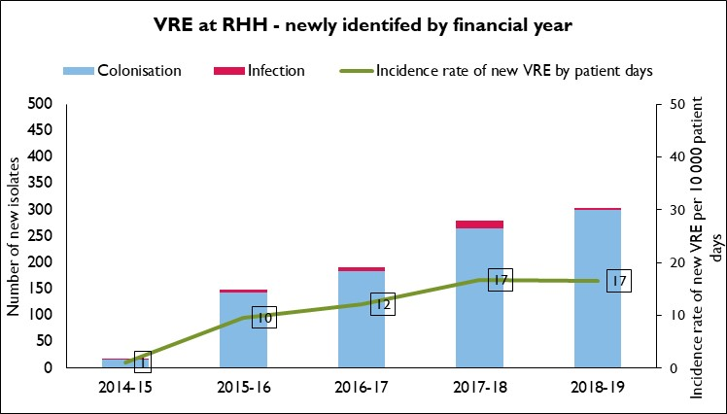
Figure 5 VRE at RHH – newly identified genotype by financial year
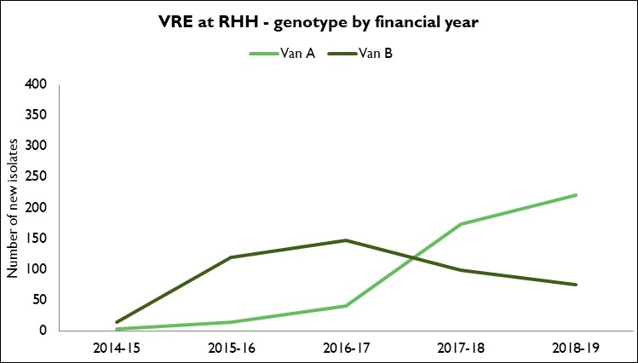

Over the last five financial years at RHH:
- There were 941 newly identified VRE with 907 (96%) colonisations and 34 (4%) infections.
- Of the 34 infections, 7 were from sterile sites (3 bloodstream, 3 tissue and 1 non-specified sterile site), 13 were urine, 9 were wounds, 4 were from drain fluid and 1 was an abscess.
- A significant increase in VRE identification occurred in late 2015 with the predominant strain being vanB E. faecium.
- Typing of a sample of VRE isolates identified at RHH from 2014 – 2016 identified:
- For vanB E. faecium isolates, ST796 was the dominant strain.
- For vanA E. faecium isolates, ST80 and ST1421 were the dominant strains.
- From Q4 2017, there was a significant change to the epidemiology of VRE within the RHH with a shift from vanB E. faecium to vanA E. faecium. Further typing was undertaken of all vanA E. faecium isolates for April-May 2018 and >95% of the isolates were ST1424 vanA E. faecium.
- Over the last two financial years, the incidence rate for newly identified VRE colonisation or infection has remained stable at14 per10,000 patient days. This may suggest that the VRE management strategies that have been implemented have been effective in controlling VRE within the RHH.
- The burden of infection at RHH in the 2018 – 2019 financial year was a total of 37 VRE infections identified.
  - VRE infection was the first VRE isolate in 43% (16/37) of cases, with infections identified after colonisation making up 57% (21/37) of the total.
- Urinary tract infections represented 16/37 infections (43%) with sterile site infections (9/37, 24%) representing the next highest category of infection.
- Of the 9 sterile site infections, 2 were bloodstream infections, 4 were ‘other sterile site’ infections and 3 were from tissue. This equates to a VRE sterile site rate of 0.11 per10 000 patient days and a VRE bloodstream infection rate of 0.02 per 10 000 patient days.

Launceston General Hospital (LGH)
Figure 6 VRE at LGH – newly identified by financial year
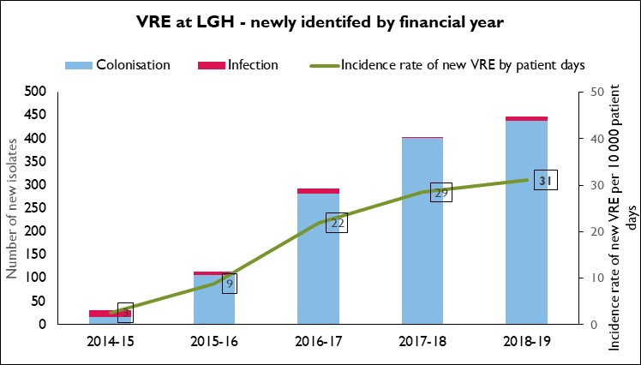
Figure 7 VRE at LGH – newly identified genotype by financial year
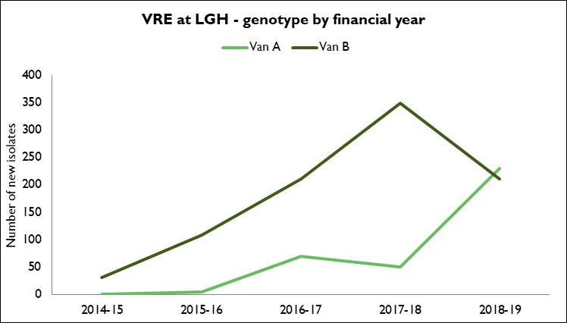

Over the last five financial years at LGH:
- There were 1289 newly identified VRE with 1243 (96%) colonisations and 46 (4%) infections.
- Of the 46 infections, just under half (20/46, 43%) were from sterile sites (13 bloodstream, 1 tissue and 6 ‘other sterile site’, 15 were urine, 8 were wounds, 2 were from drain fluid and 1 was from sputum.
- A significant increase in VRE identification occurred in late 2015 with the predominant strain being vanB E. faecium.
- Typing of a sample of VRE isolates identified at LGH from 2014 – 2016 identified:
- For vanB E. faecium isolates, ST796 was the dominant strain.
- For vanA E. faecium isolates, ST1421 was the dominant strain.
- No further typing has been done of the vanA E. faecium isolates subsequently. It is possible that a different dominant vanA E. faecium ST is now present at the LGH with the recent shift from vanB E. faecium to vanA E. faecium similar to what has occurred at RHH.
- Over the last two financial years, the incidence for newly identified VRE colonisation or infection has remained stable at 29 – 31 per10,000 patient days. This stability suggests that the VRE management strategy that has been implemented has been effective in controlling VRE within the LGH.
- The burden of infection at LGH in the 2018 – 2019 financial year was a total of 22 VRE infections identified.
  - VRE infection was the first isolate in 41% (9/22) of cases, with infections identified after colonisation making up the remaining 59% (13/22).
- Sterile site (9/22) and urinary tract infections (9/22) both represented 41% of these infections with the remainder being wound infections (2), sputum (1) and from drain fluid (1).
- Of the 9 sterile site infections, 7 were bloodstream infections, 1 was from an intrabdominal infection and 1 was from tissue. This equates to a VRE sterile site rate of 0.62 per10 000 patient days and a VRE BSI rate of 0.48 per10 000 patient days.

North West Regional Hospital (NWRH)
Figure 8 VRE at NWRH – newly identified by financial year
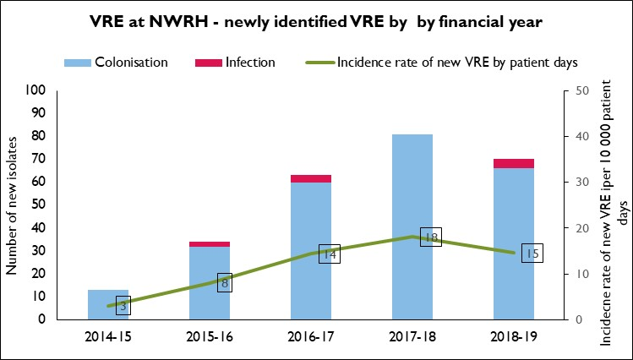
Figure 9 VRE at NWRH – newly identified genotype by financial year
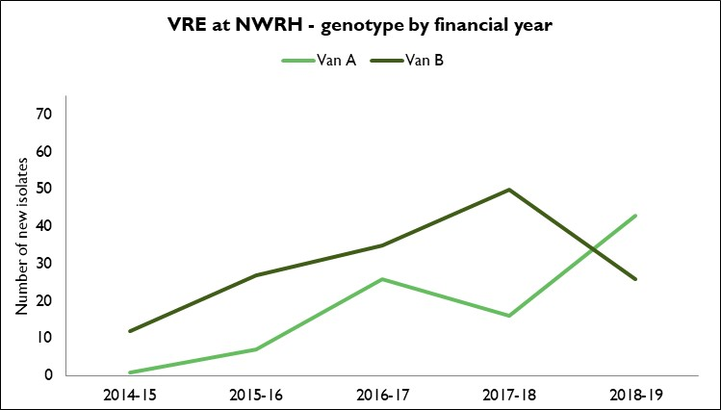

Over the last five financial years at NWRH:
- There were 261 newly identified VRE with 254 (97%) colonisations and 7 (3%) infections.
- Of the 7 infections, 1 was from a sterile site (ascitic fluid), 4 were urine, 1 was a wound and 1 was from drain fluid.
- A significant increase in VRE identification occurred in late 2015 with the predominant strain being vanB E. faecium until 2018 – 2019.
- Typing of a sample of VRE isolates identified at NWRH from 2017 identified:
- For vanB E. faecium isolates, ST796 was the dominant strain.
- For vanA E. faecium isolates, ST1421 was the dominant strain.
- Over the last three financial years, the incidence rate for newly identified VRE colonisation or infection has remained stable at 15 per10,000 patient days. This stability suggests that the VRE management strategy that has been implemented has been effective in controlling VRE within the NWRH.
- The burden of infection at NWRH in the 2018 – 2019 financial year was a total of 5 VRE infections identified.
  - VRE infection was the initial VRE isolate in 80% (4/5) of cases, with infections identified after colonisation making up the remaining 20% (1/5).
- There was 1 sterile site infection (ascitic fluid), 3 urinary tract infections and 1 wound infection. This equates to a VRE sterile site rate of 0.50 per10 000 patient days.

Mersey Community Hospital (MCH)
Figure 10 VRE at MCH – newly identified by financial year
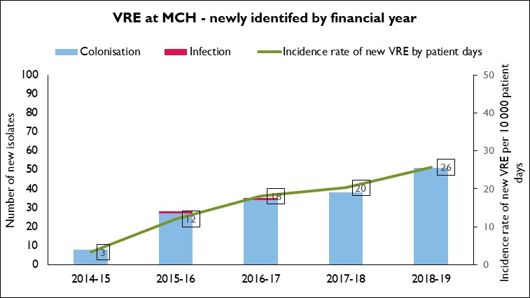
Figure 11 VRE at MCH – newly identified genotype by financial year
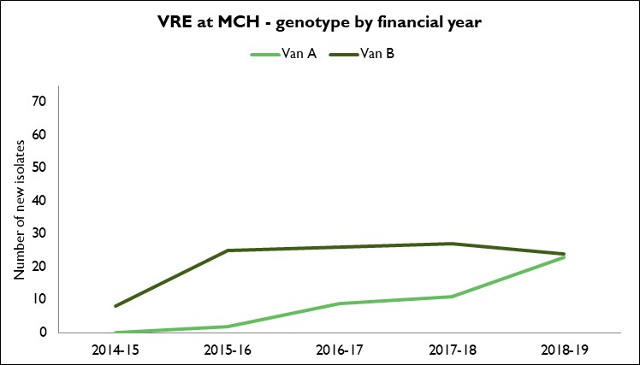

Over the last five financial years at MCH:
- There were 160 newly identified VRE with 158 (99%) colonisations and 2 (1%) infections.
- Of the 2 infections, 1 was from a sterile site (bloodstream), and 1 was from urine.
- A significant increase in VRE identification occurred in late 2015 with the predominant strain being vanB E. faecium.
- Typing of a sample of VRE isolates identified at NWRH from 2017 identified:
- For vanB E. faecium isolates, ST796 was the dominant strain.
- For vanA E. faecium isolates, ST1424 was the dominant strain similar to the dominant strain at RHH identified in 2018.
- The incidence rate for newly identified VRE colonisation or infection has been steadily increasing with the incidence in 2018 – 2019 being 26 per10 000 patient days.
- There were no infections identified in 2018 – 2019 at MCH.

Key findings
The key findings of this report are:
- The number of individuals with VRE colonisation and/or infection in Tasmania increased significantly from 2015. This was initially related to an increase in vanB E. faecium, but since 2016, there has been a shift from vanB to vanA E. faecium with vanA E. faecium with vanA E. now representing 60% of all VRE identified.
  - ST796 has been identified as the dominant vanB E. faecium strain within public hospitals in Tasmania which is similar to what has been observed nationally due to its widespread dissemination throughout South East Australia.
  - The epidemiology of vanA E. faecium within the public hospitals in Tasmania has been changing with ST1421 and ST1424 being the dominant vanA E. faecium strains identified. This has mirrored the dramatic polyclonal increase and dissemination of vanA. E. faecium identified across Australia.
  - Ongoing molecular typing would be required to maintain an understanding of the changing epidemiology of VRE in Tasmania.
  - Newly identified infections represent only around half of the total infections caused by VRE.
  - Surveillance of people who present with an infection following an initial colonisation will continue to be monitored to give a more accurate picture of the burden of VRE infection.
  - Most infections are urinary tract infections but 14% of the total are blood stream infections.
  - There is currently no national standardised surveillance system for the collection and presentation of VRE infection data, including VRE bloodstream infection data, at either a healthcare facility level or a state/territory jurisdiction level, so currently it is not possible to compare Tasmanian VRE data with other jurisdictions.

References
- AGAR Australian Enterococcal Sepsis Outcome Program (AESOP). Reports including the 2019 Final Report.
- AURA 2019. Third Australian Report on Antimicrobial Use and Resistance in Human Health
- Australian Bureau of Statistics. Retrieved from www.abs.gov.au/ausstats/abs@.nsf/second+level+view?ReadForm&prodno=3218.0&viewtitle=Regional%20Population%20Growth,%20Australia~2009-10~Previous~31/03/2011&&tabname=Related%20Products&prodno=3218.0&issue=2009-10&num=&view=&; www.abs.gov.au/AUSSTATS/abs@.nsf/allprimarymainfeatures/30125843DE7F366ECA2582570013F5FE?opendocument and www.abs.gov.au/AUSSTATS/abs@.nsf/allprimarymainfeatures/E18EA7BE5701F459CA2583C3000C53C8?opendocument
- Ferguson JK et al. Reduced VRE and MRSA colonisation and infection following sustained reduction in broad spectrum antibiotic use in a large tertiary hospital.
- Leong K.W.C. et al (2018), Emergence of Vancomycin Resistant E. faecium at an Australian Hospital: A Whole Genome Sequencing Analysis. Scientific Reports (2018); 8: 6274
- Leong K.W.C et al (2019). State-Wide Genomic and Epidemiological Analyses of Vancomycin-Resistant Enterococcus faecium in Tasmania’s Public Hospitals.
- Leong K.W.C et al (2018). Draft Genome Sequence of New Vancomycin-Resistant E. faecium Sequence Type 1421. American Society For Microbiology; Vol 6: Issue 20
- Van Hal SJ et al. Relentless spread and adaptation of non-typeable vanA VREfm: a genome-wide investigation. J Antimicrobial Chemother 2018 June 1;73(6):1487-91
- Wilson, F, Hughson, L, Anderson, T and Wells, A (2018), Vancomycin resistant enterococci (VRE) surveillance protocol V4, Hobart: Department of Health and Human Services.

