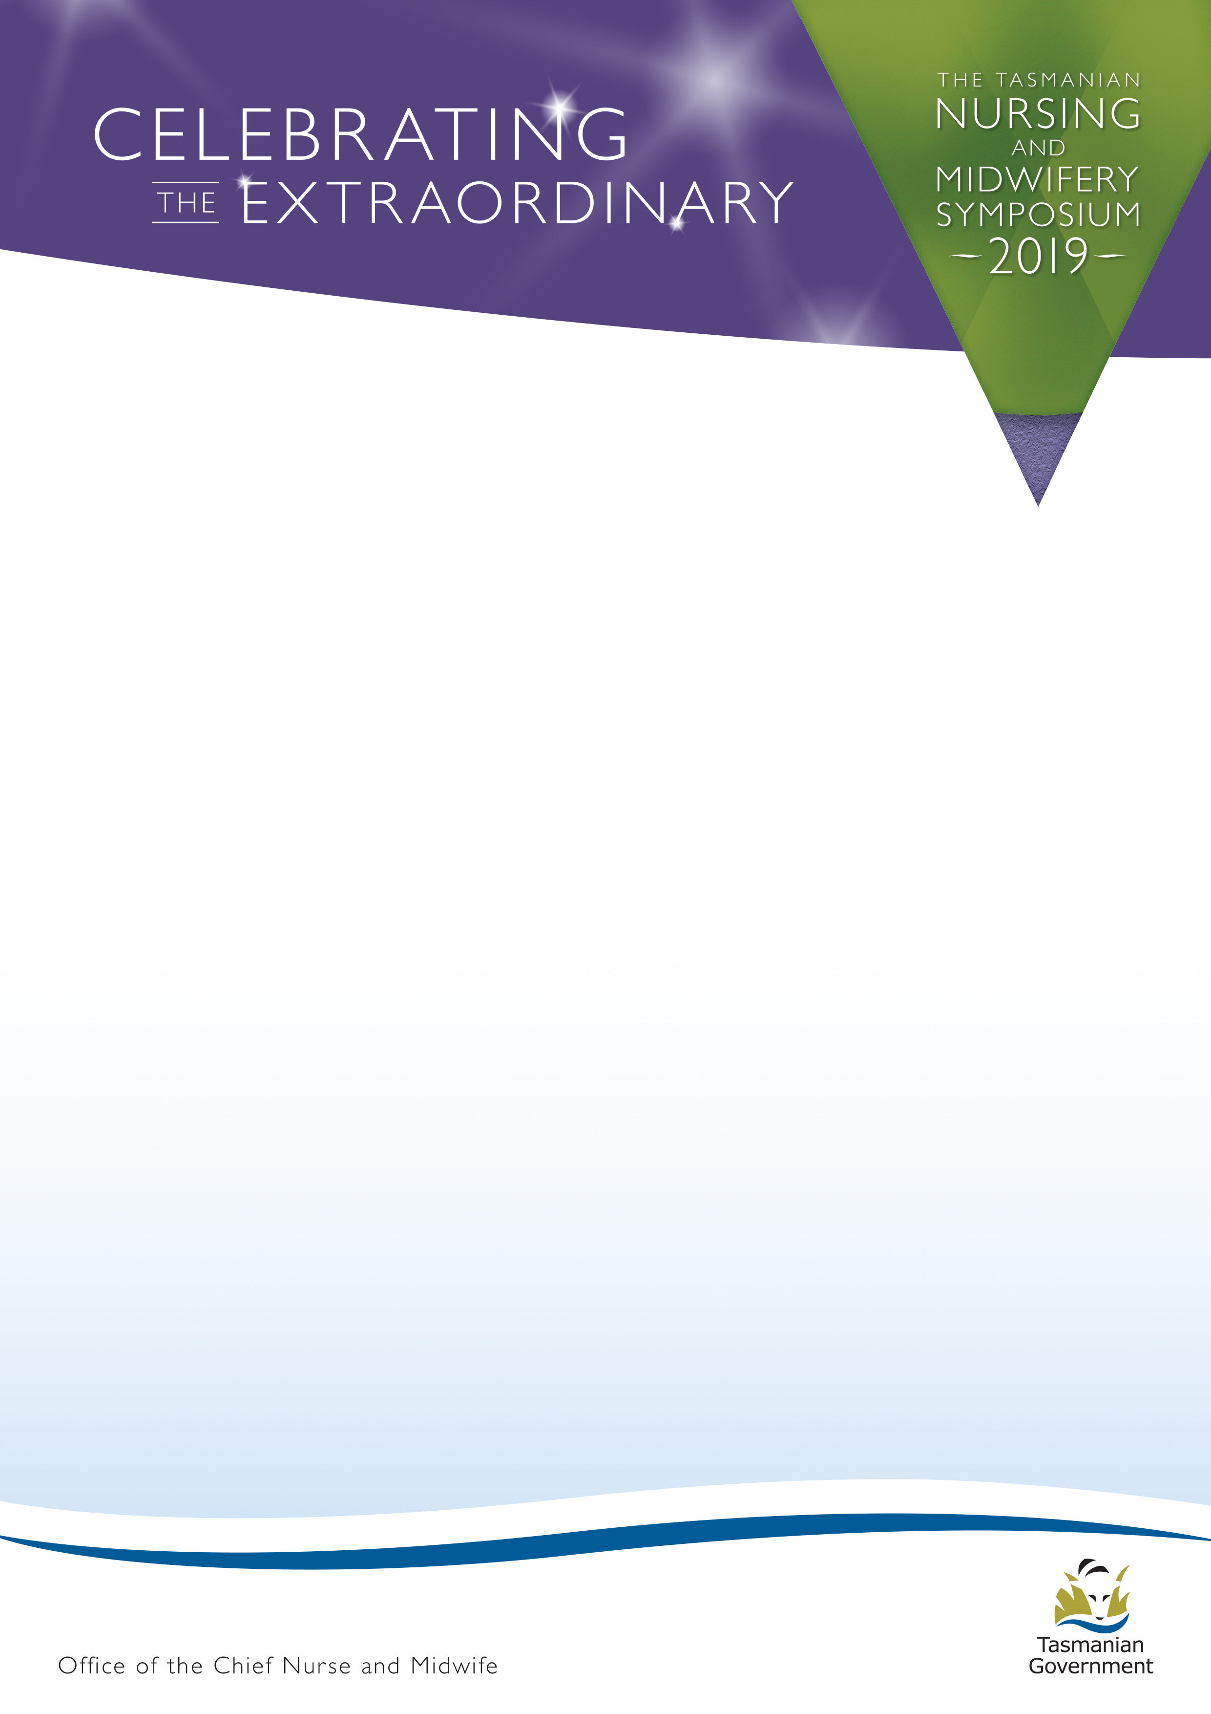

ABSTRACT SUBMISSION

Please complete all sections of the form and email to
naomi@eventsphere.com.au no later than 11:59pm Friday 26 October 2018

If you have any questions, please do not hesitate to call Naomi on 0439 336 511.

Your abstract submission must be received on time, to be considered for the program of the
Tasmanian Nursing and Midwifery Symposium 2019.

Presentation Title:

Symposium Theme (please check one box only)

Outside the box – extraordinary ideas, or
Two heads are better than one – extraordinary collaboration, or
An ordinary day – extraordinary stories.

Authors:

Authors(s) affiliations:

Presenter:

Type of Abstract (please check box)

Presentation (15 minutes + 5 minutes Q & A)
Other – please specify below

Abstract (250-300)

References:

